**School of Computer Science**

**UNIVERSITY OF PETROLEUM AND ENERGY STUDIES**

**DEHRADUN, UTTARAKHAND**



System Monitoring And Configuration Management

**Lab File**

**(2023-2024)**

**for**

**6th Semester**

|  |  |
| --- | --- |
| Submitted To:  Dr. Hitesh Kumar Sharma | Submitted By:  Pragya Mittal  B. Tech. CSE DevOps  [6h Semester]  Sap id- 500090986  Batch 1  R2142210570 |

**LAB EXERCISE 1**

**Aim: Install Terraform on Windows**

Download Terraform, add it to path and verify install.

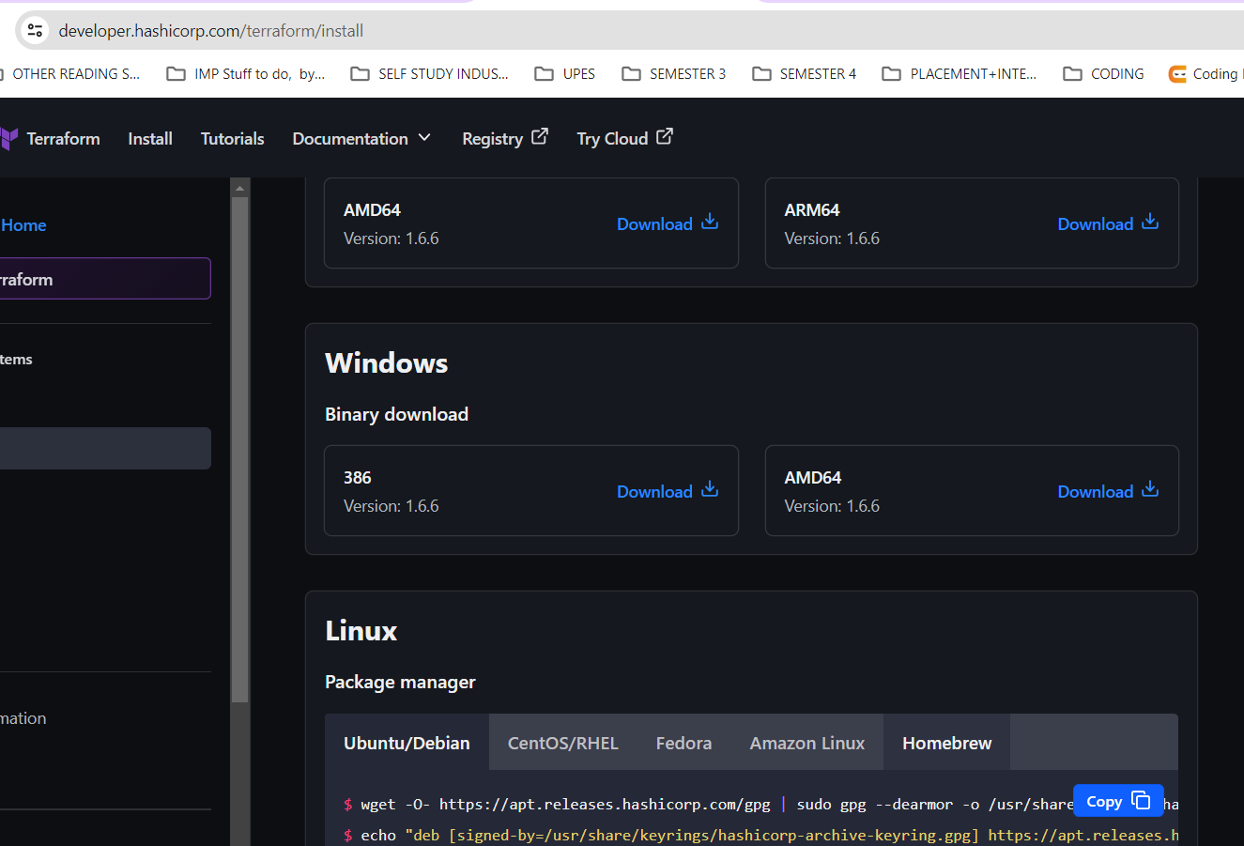

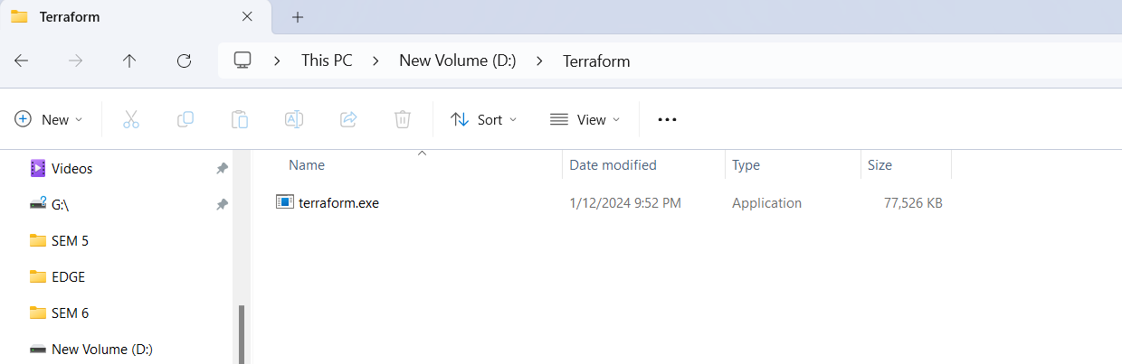

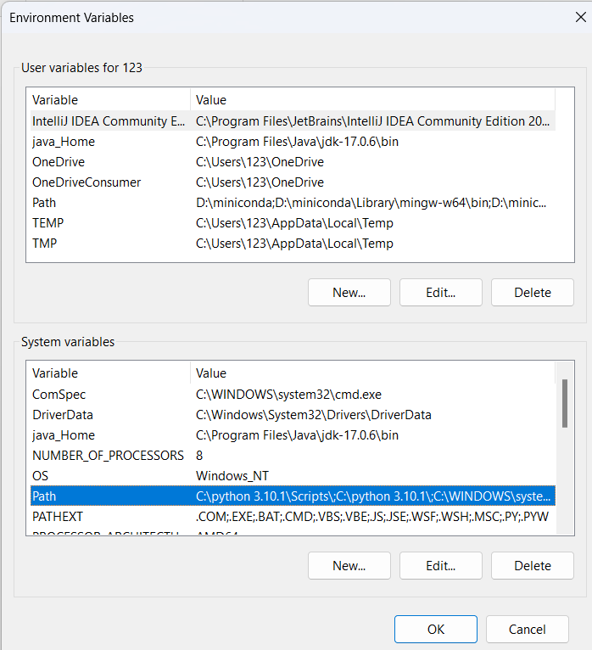

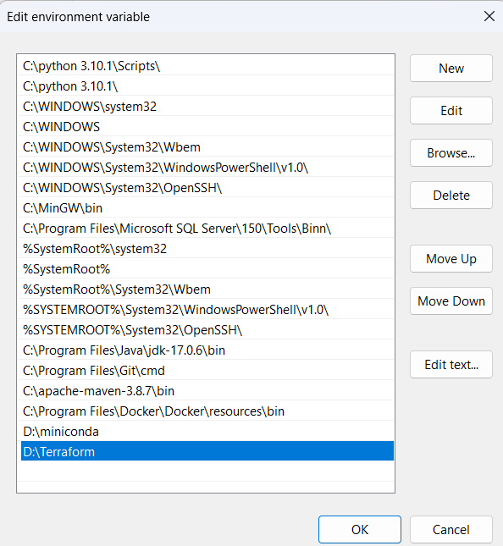

On cmd run this command for the successful installation.

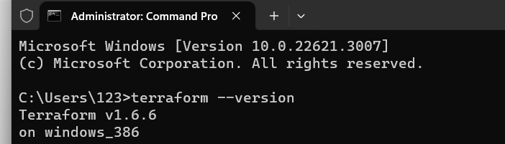

**LAB EXERCISE 2**

**Aim: Terraform AWS Provider and IAM User Setting**

Step 1:Create Terraform Configuration File (main.tf)

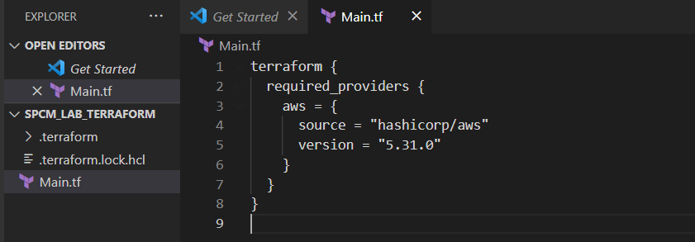

Step 3: Initialize Terraform:

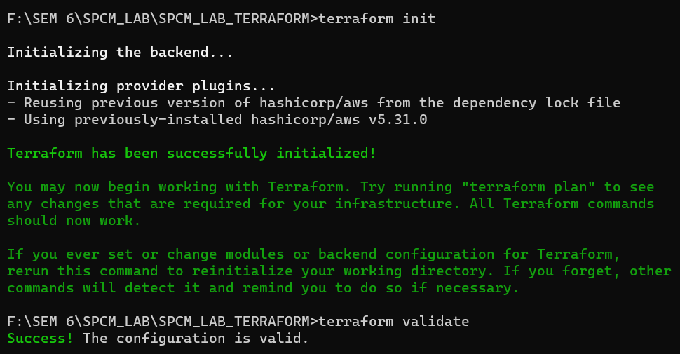

**LAB EXERCISE 3**

**Aim: Provisioning an EC2 Instance on AWS**

Step 1: Create Terraform Configuration File (main.tf)

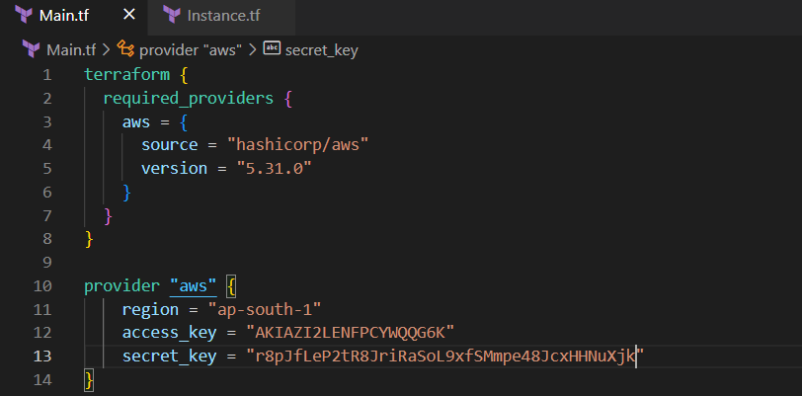

Step 2: Create Terraform Configuration File for EC2 instance (instance.tf)

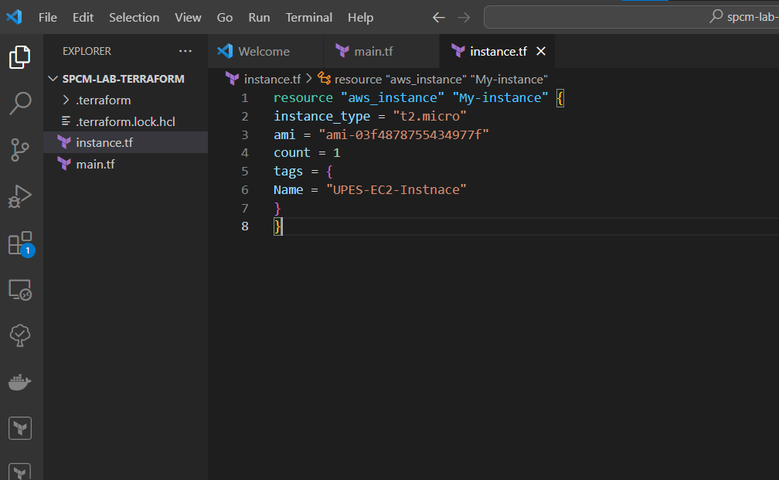

Step 3: Initialize Terraform:



Step 4: Apply Validate



Step 5: Review Plann

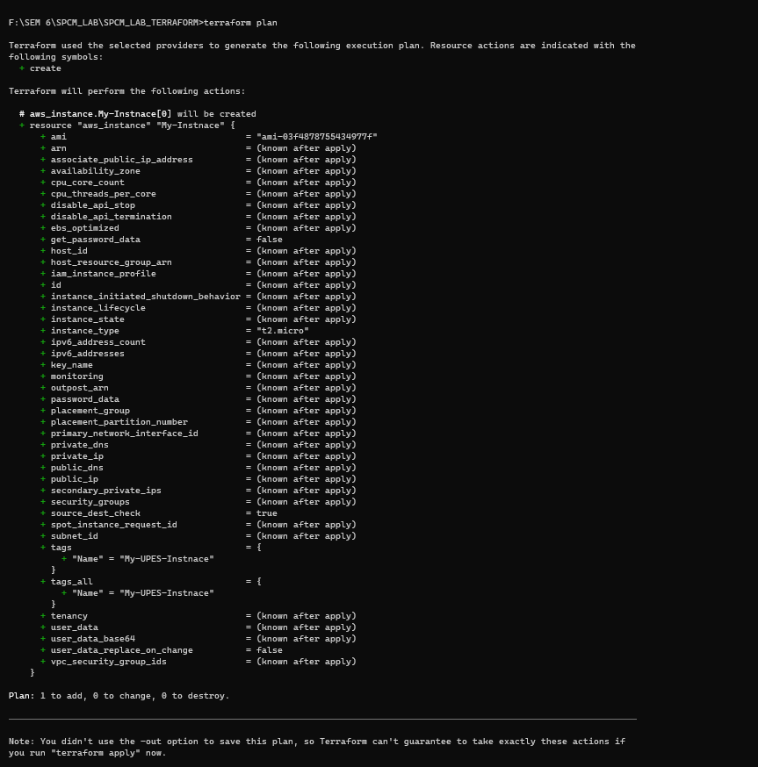

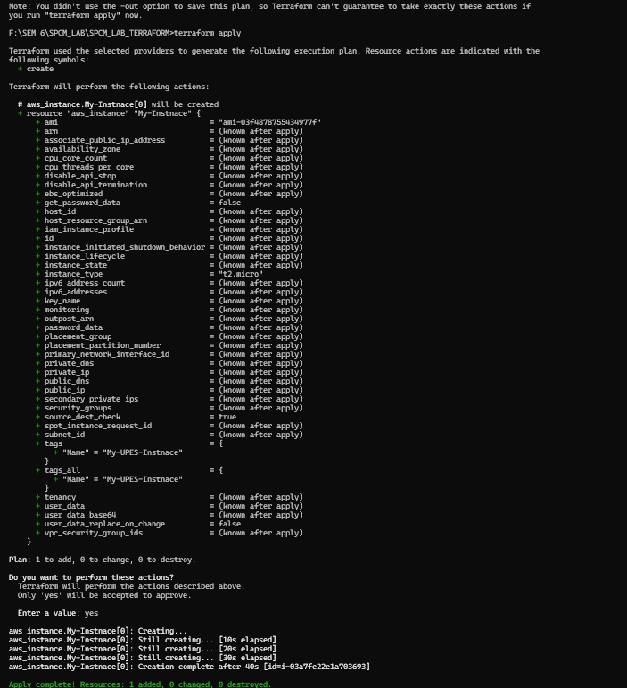

Step 6: Apply Changes

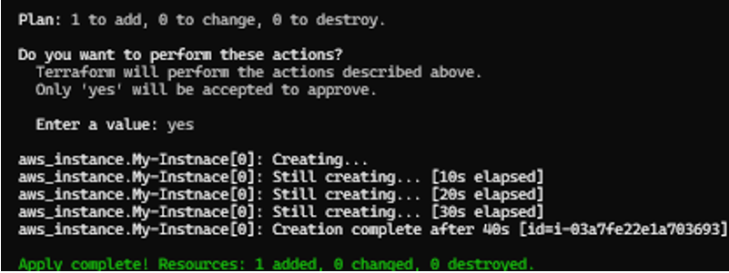

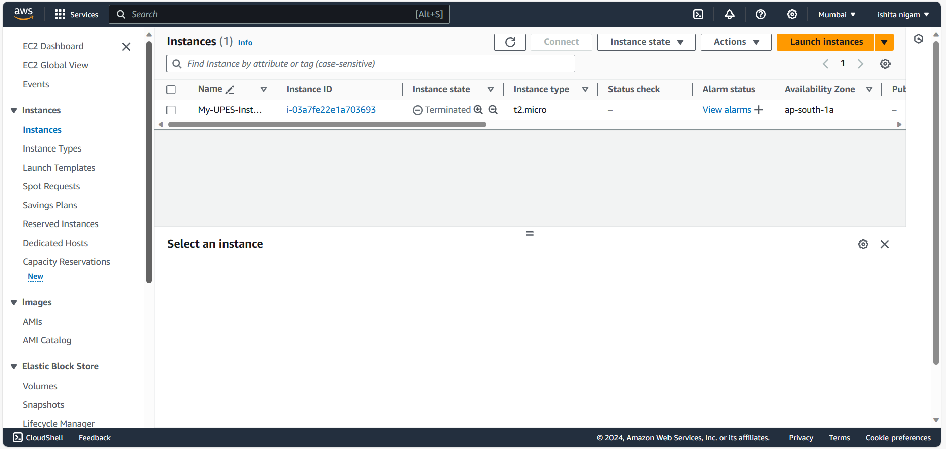

Step 7: Cleanup Resources

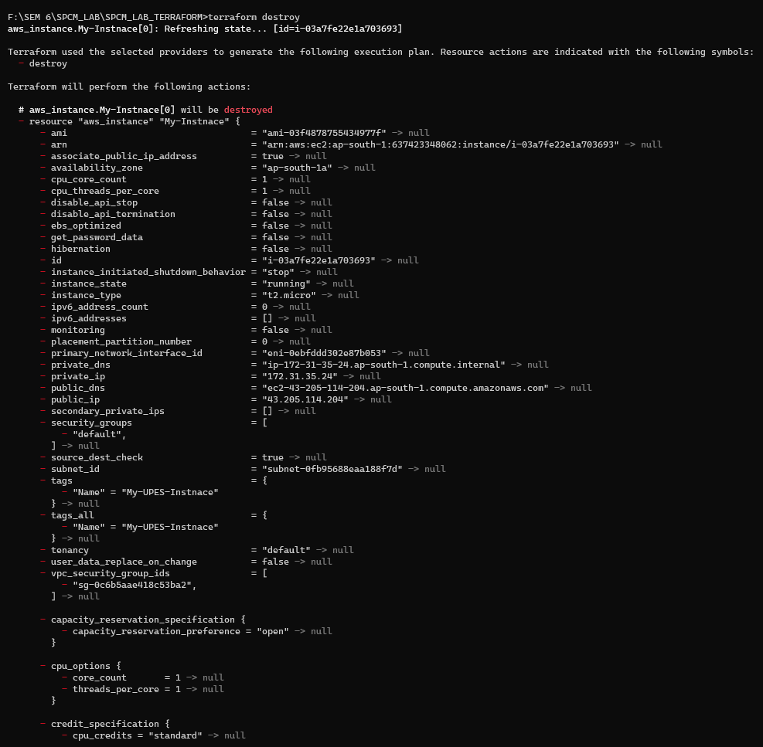

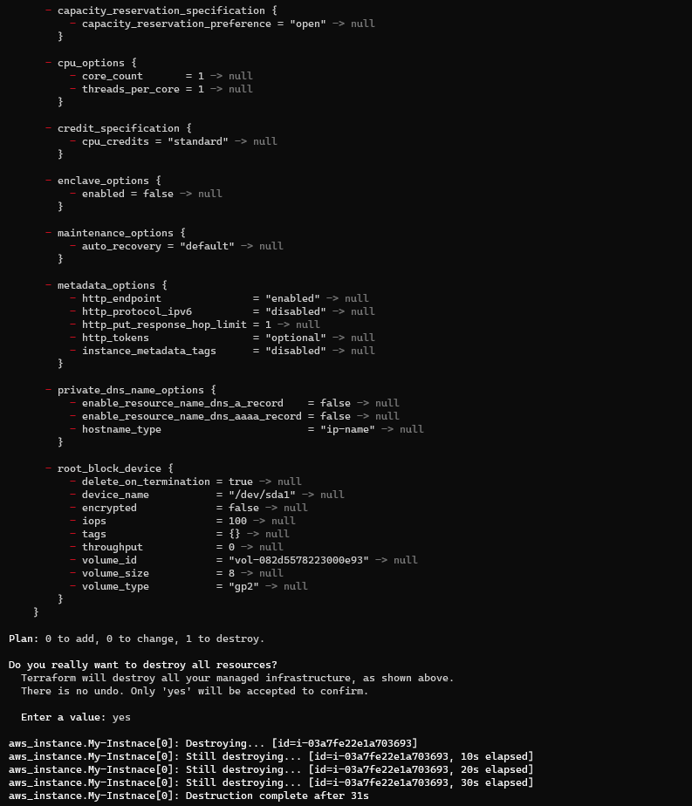



**LAB EXERCISE 4**

**Aim: Terraform Variables**

Step 1: Create a Terraform Configuration File:

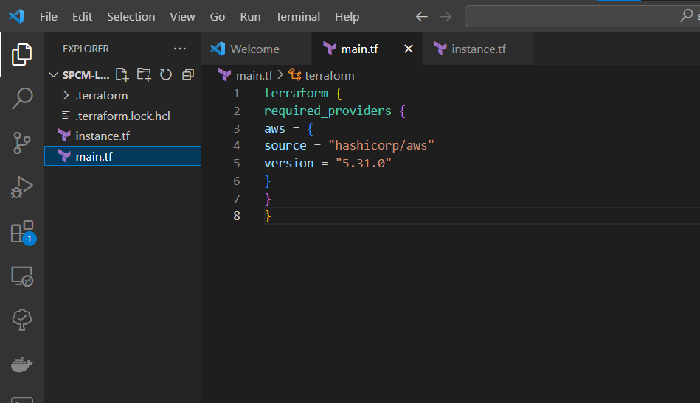

Step 2: Define Variables:

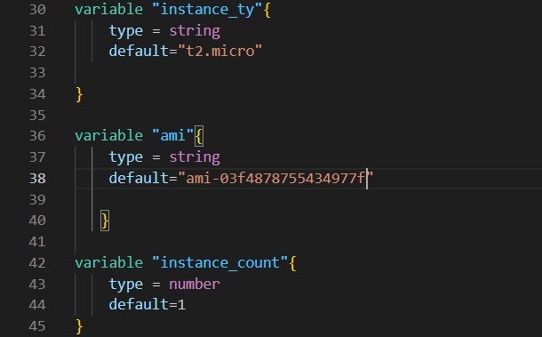

Step 3: Use Variables in instance.tf file:

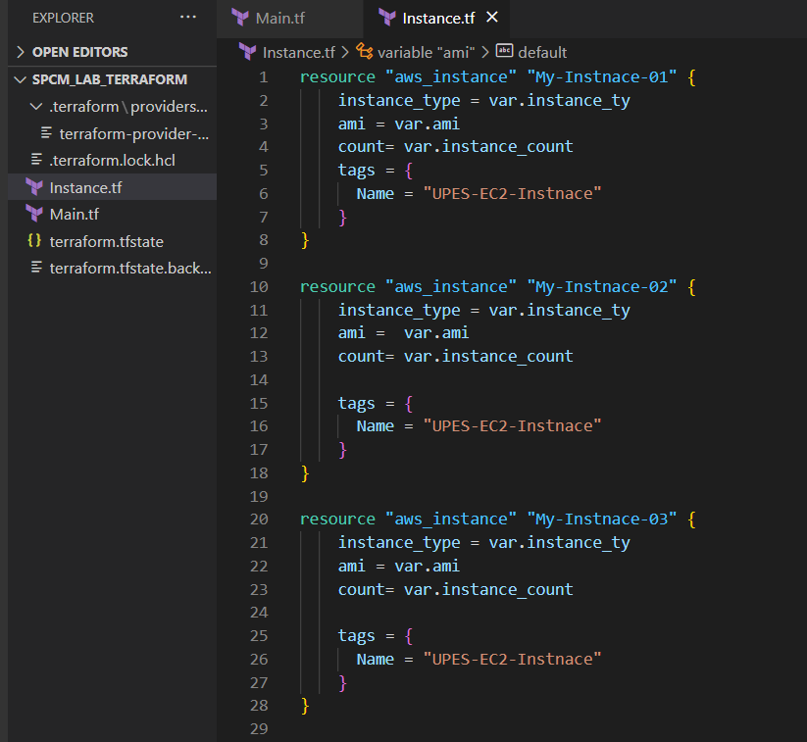

Step 4: Now do terraform initialize:

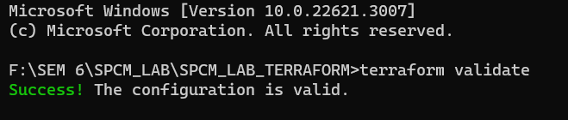

Step 5: Now perform Terraform plan:

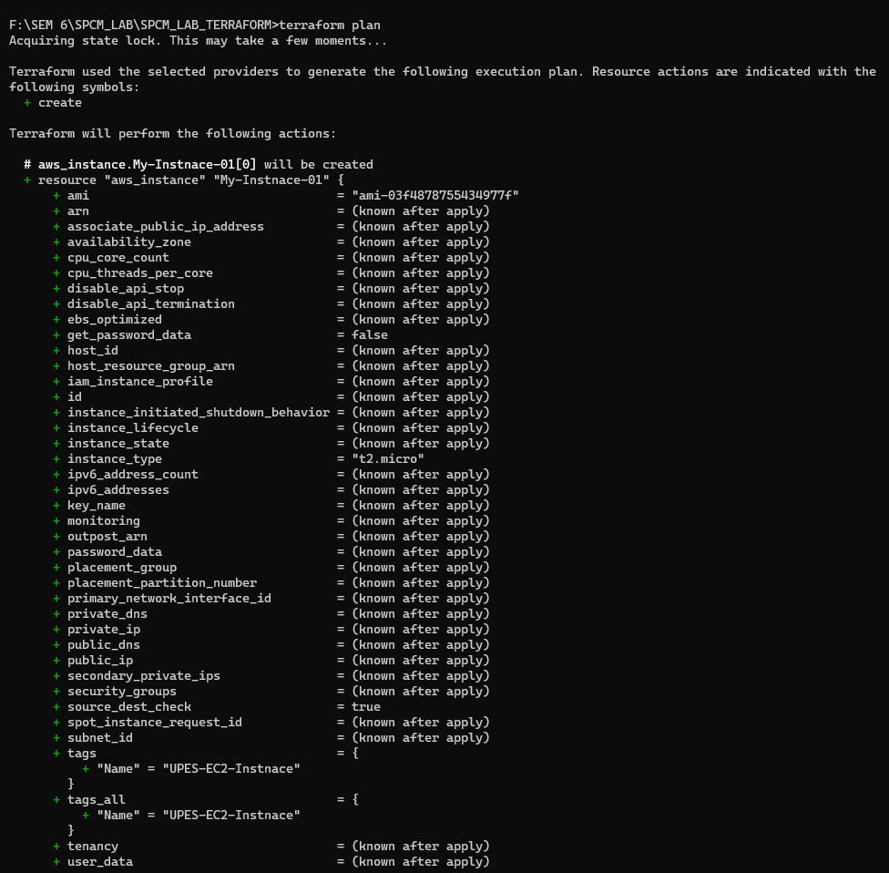

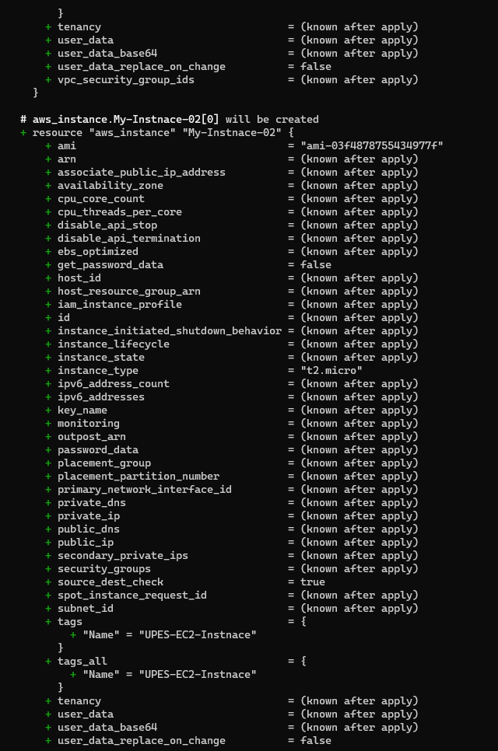

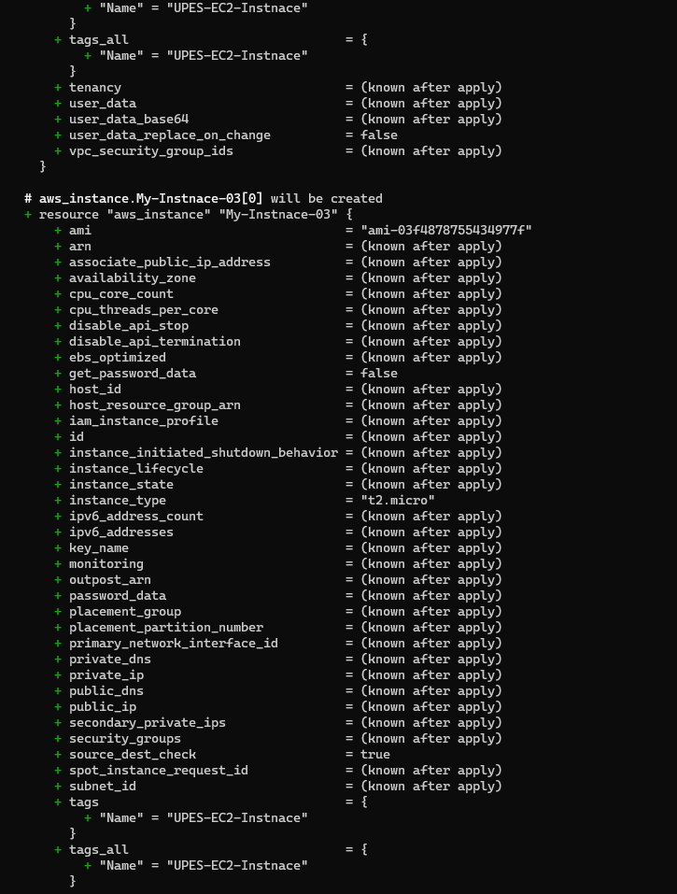

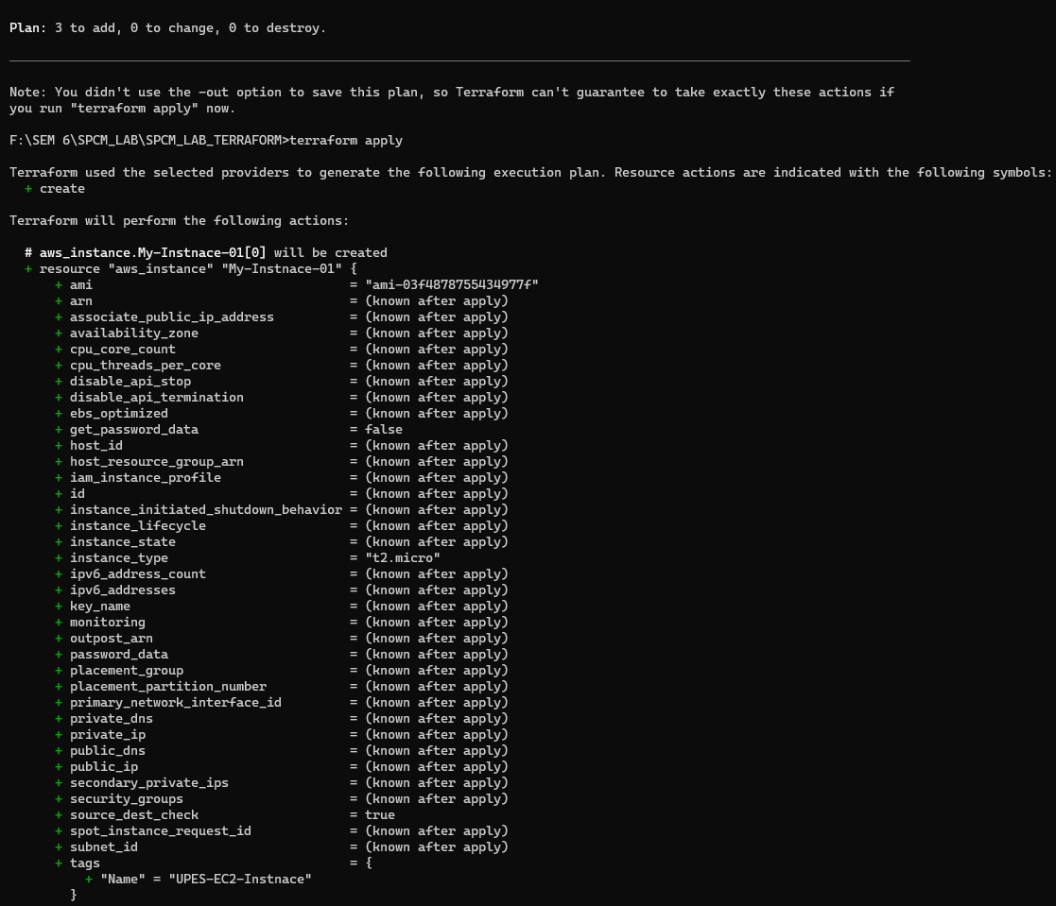

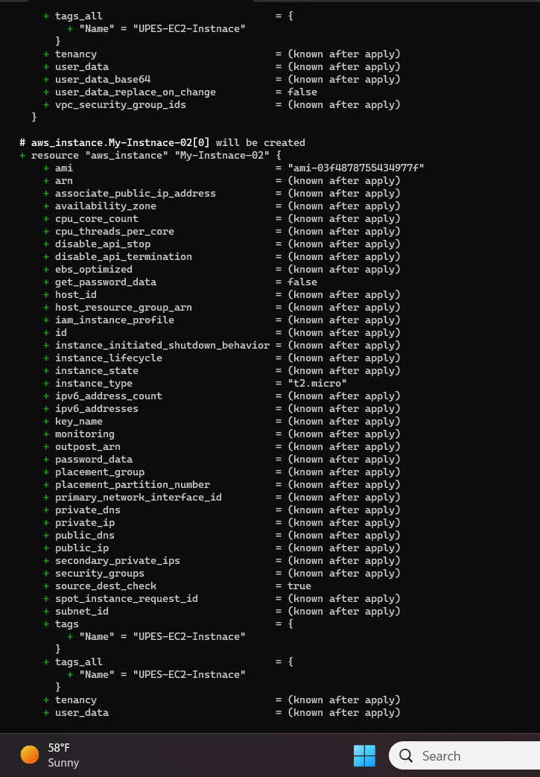

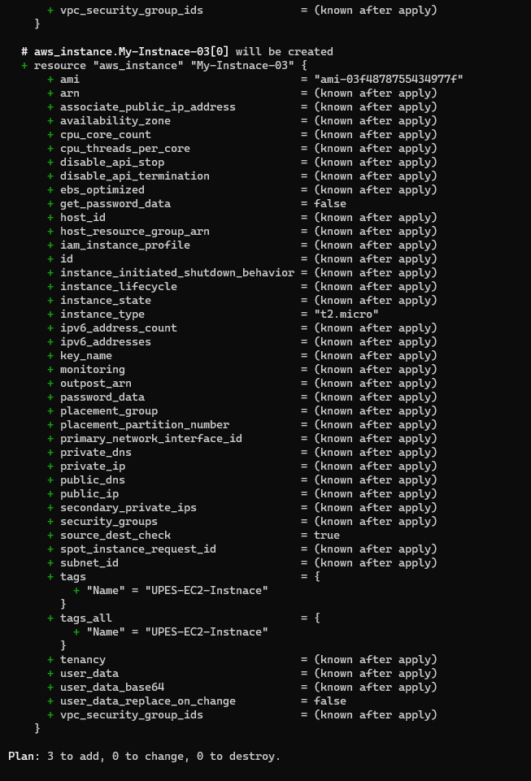

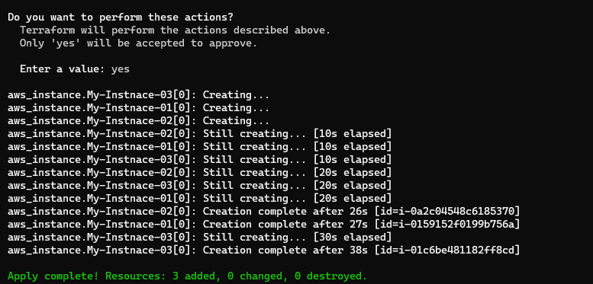

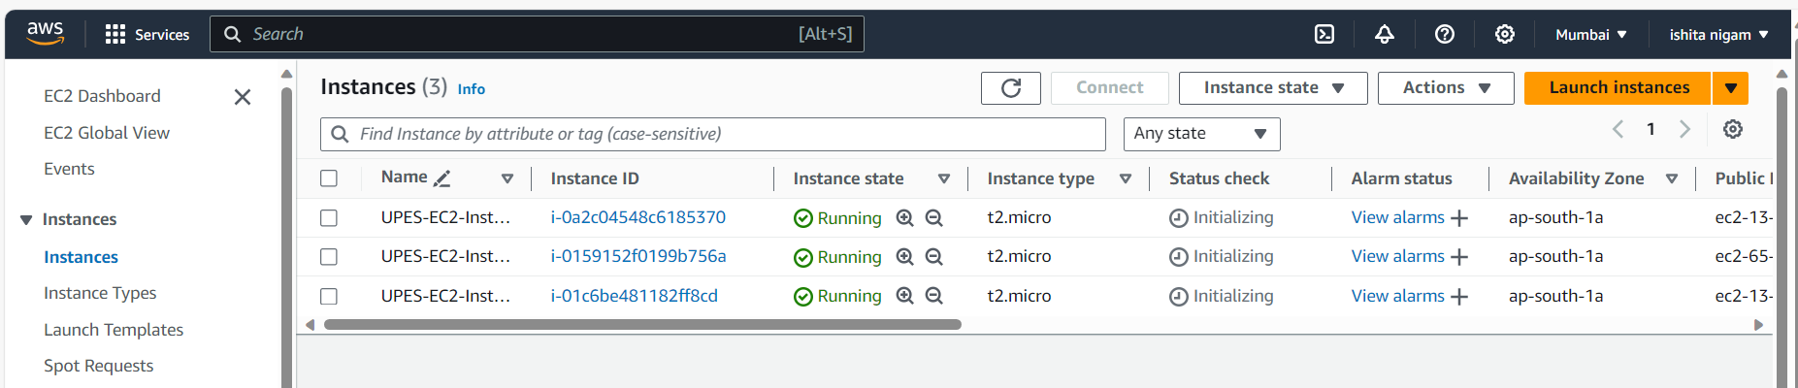

Step 6: Now perform Terraform Destroy to clean up:

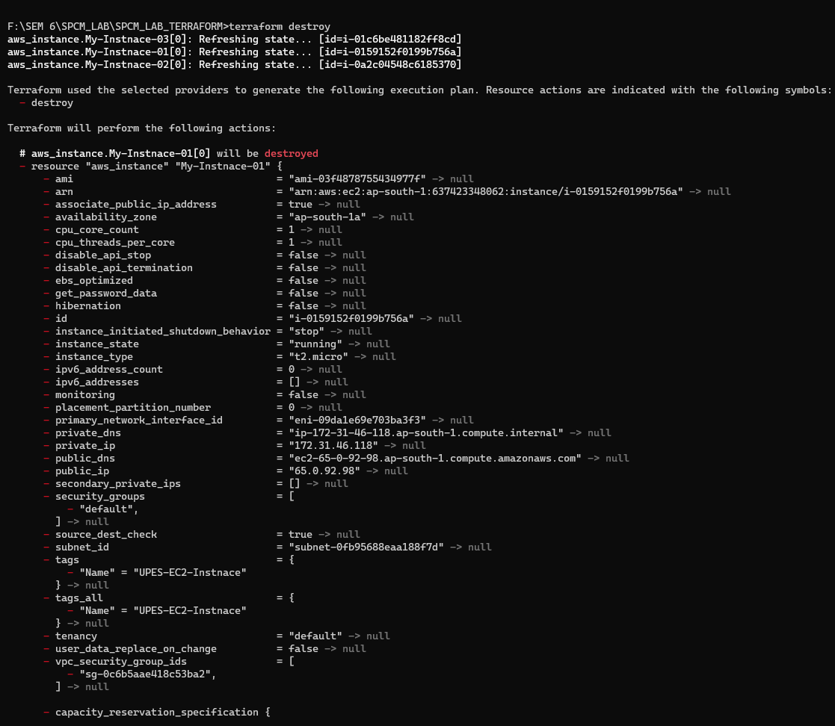

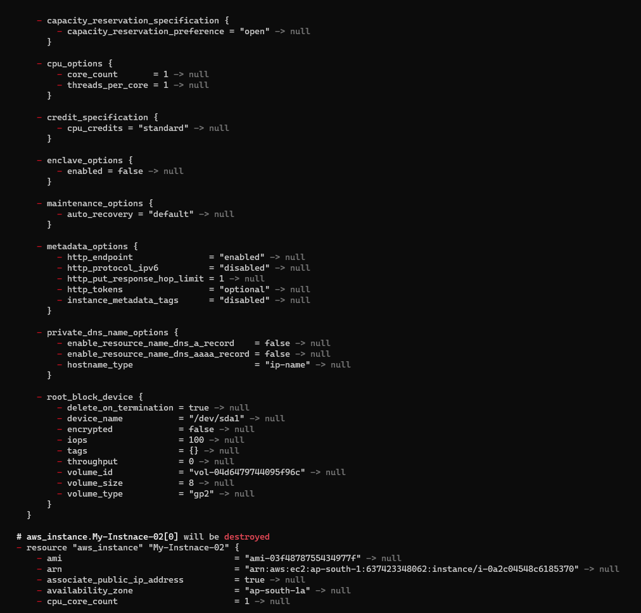

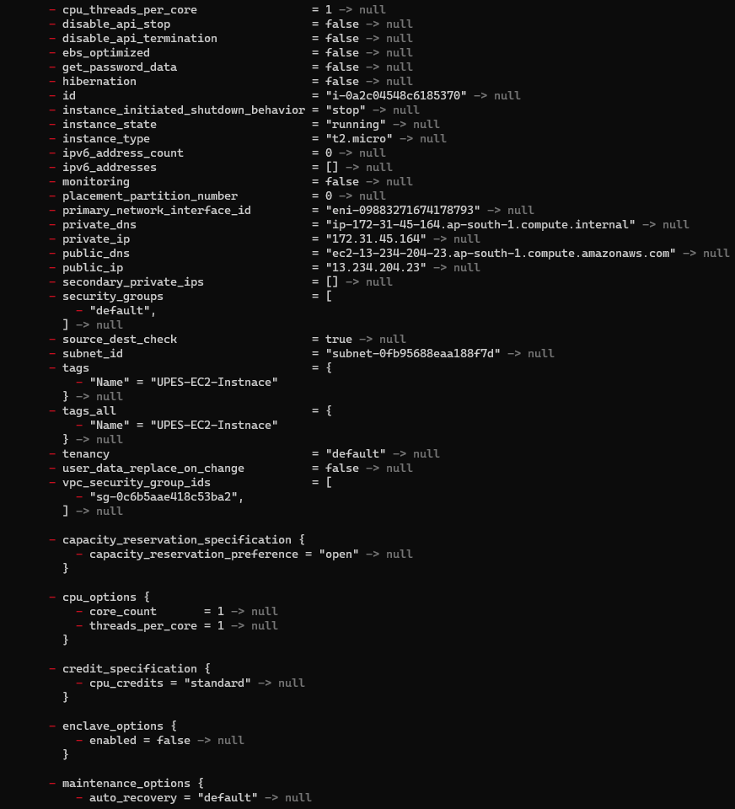

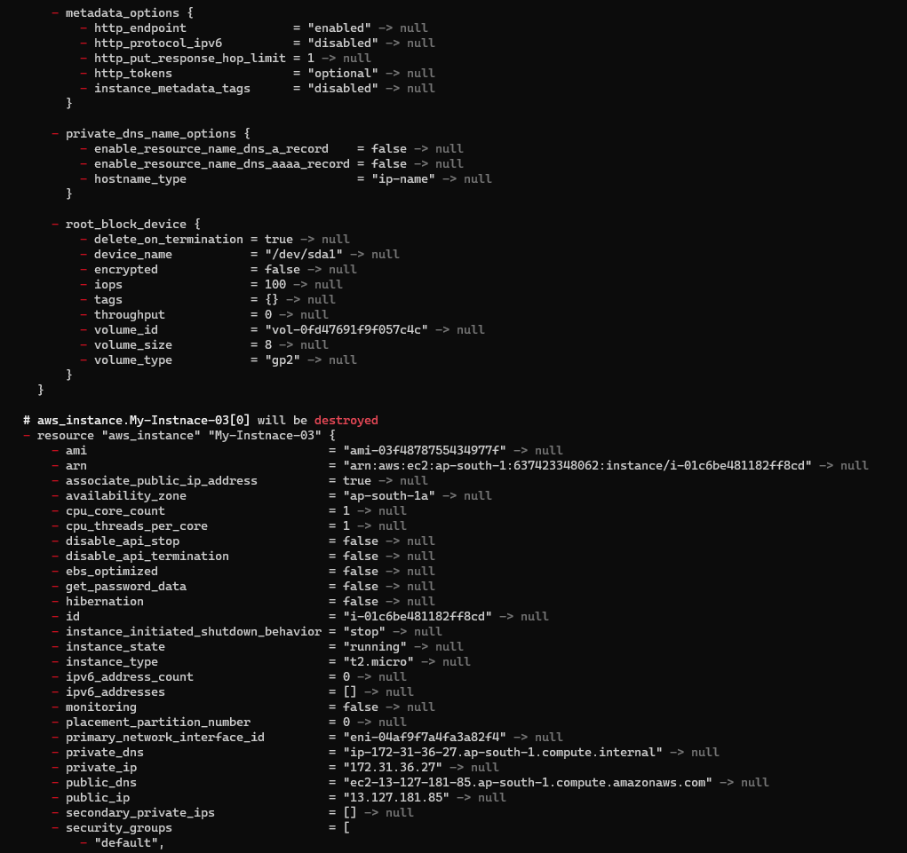

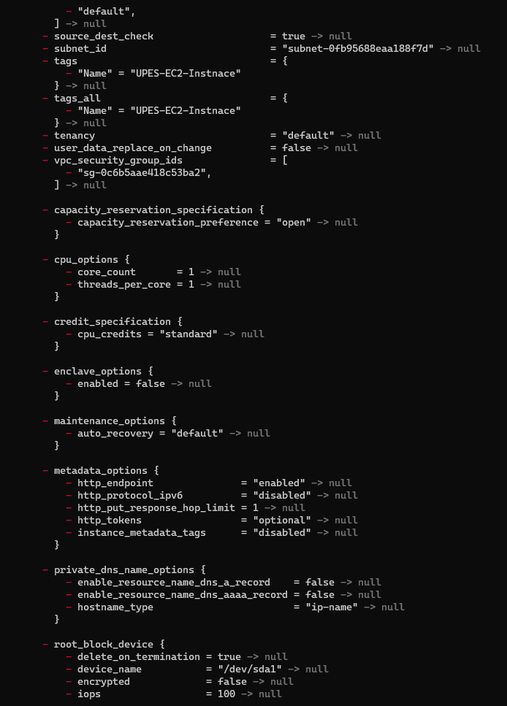

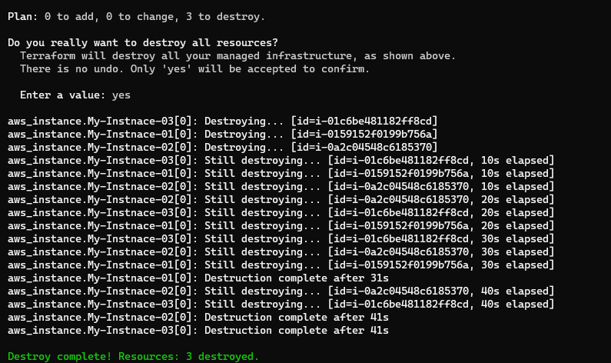

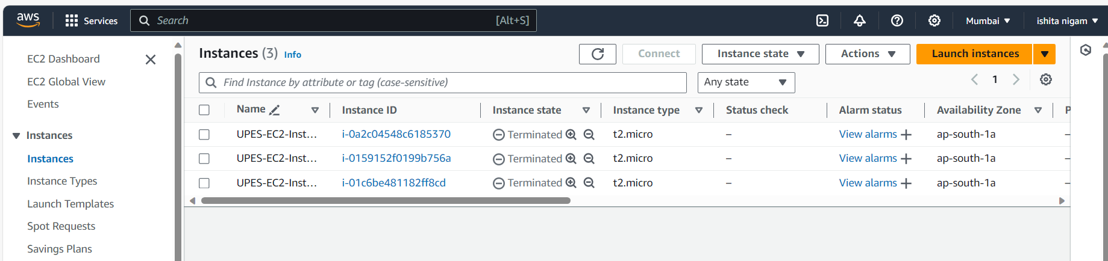

**LAB EXERCISE 5**

**Aim:** Terraform Variables with Command Line Arguments

Step 1: Create a instance.tf file:

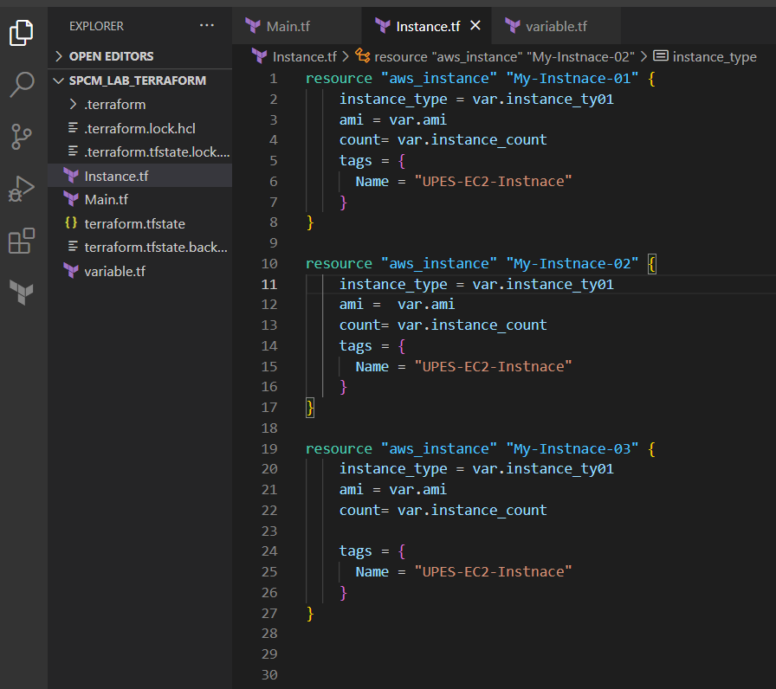

Step 2: Create a variable.tf file

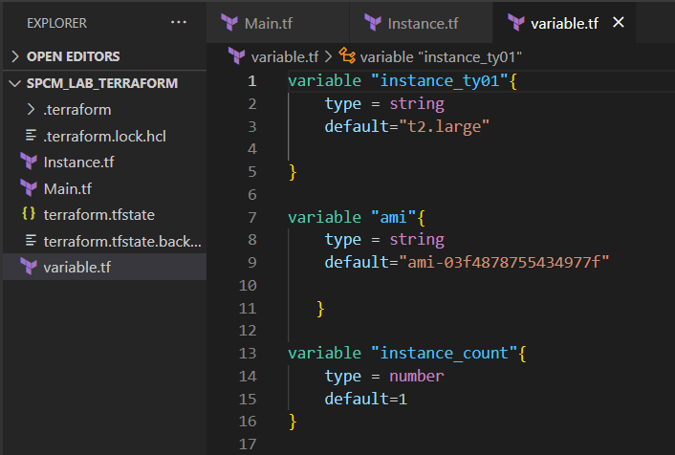

Step 3: Perform Terraform Validate And Apply

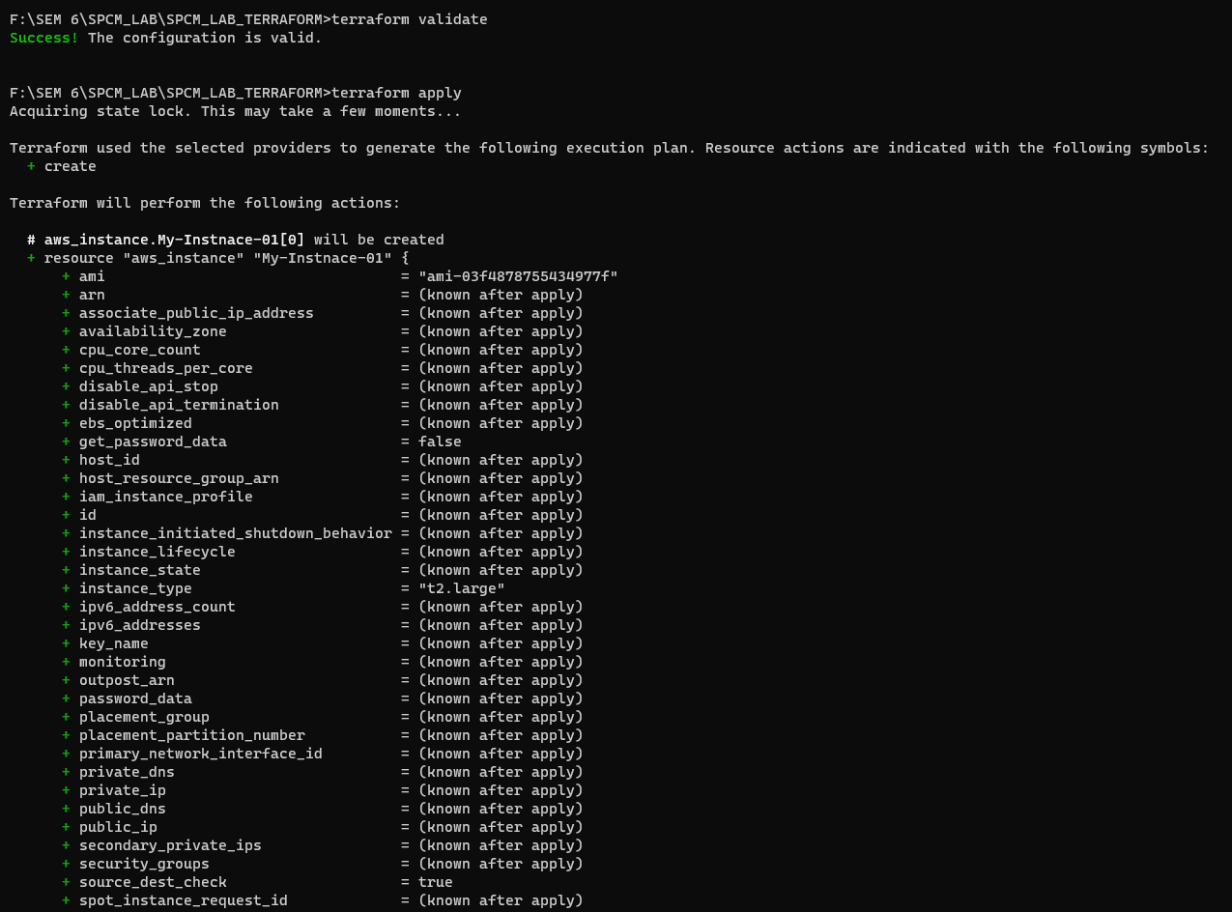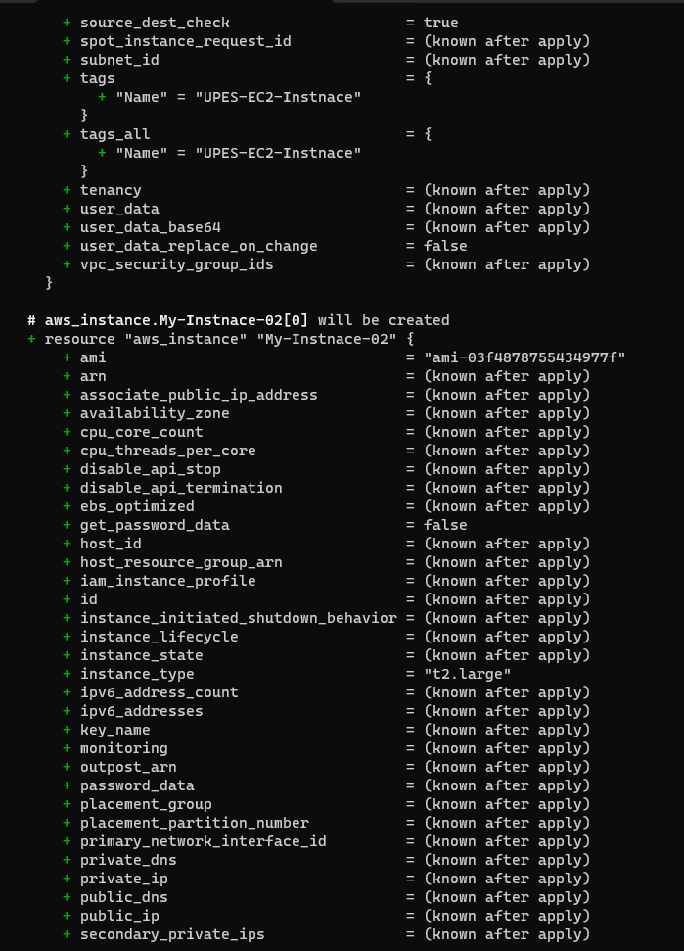

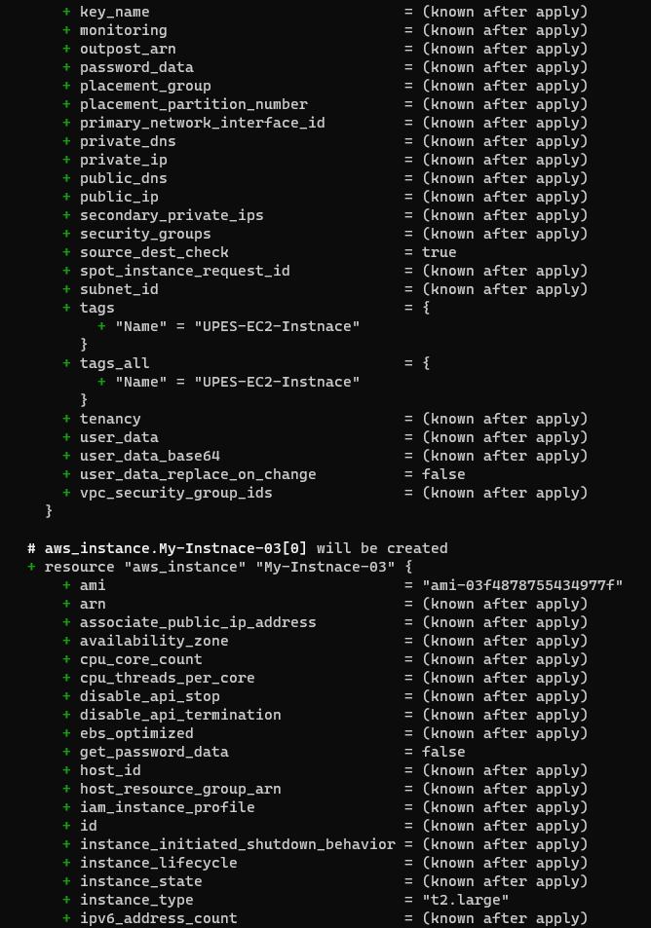

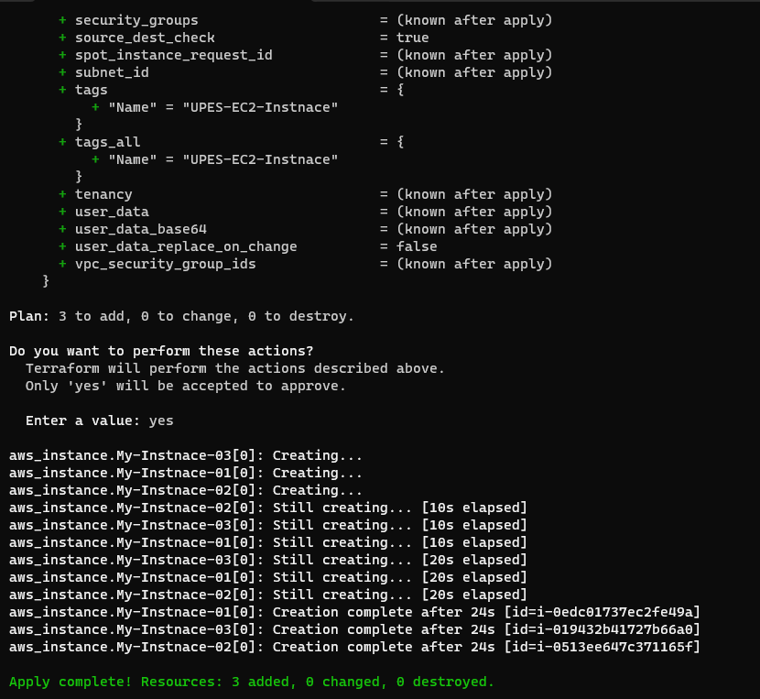

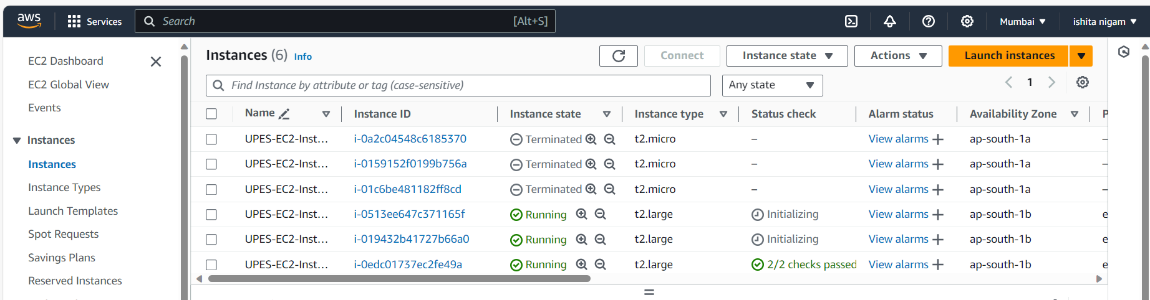

Step 4: Perform Terraform Destroy:

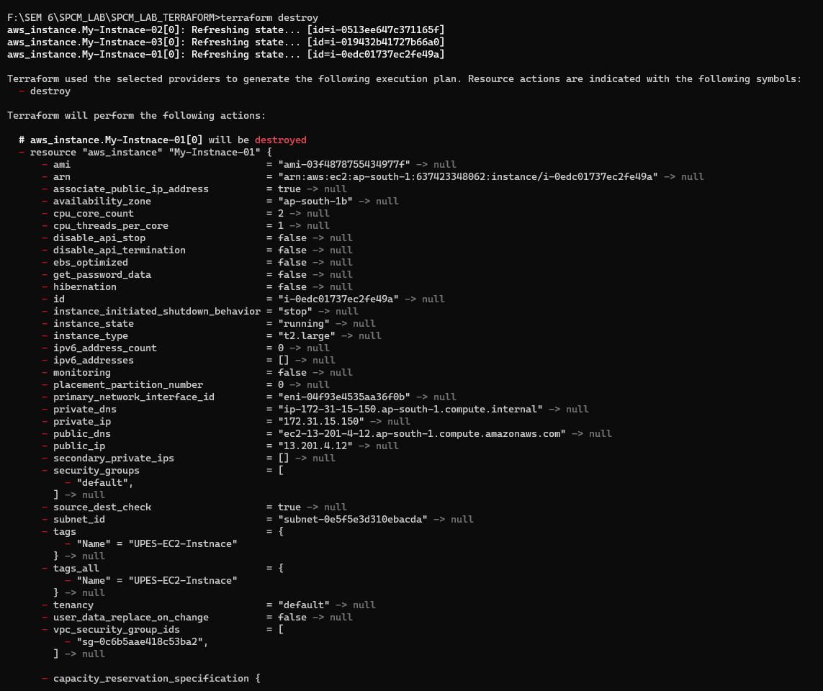

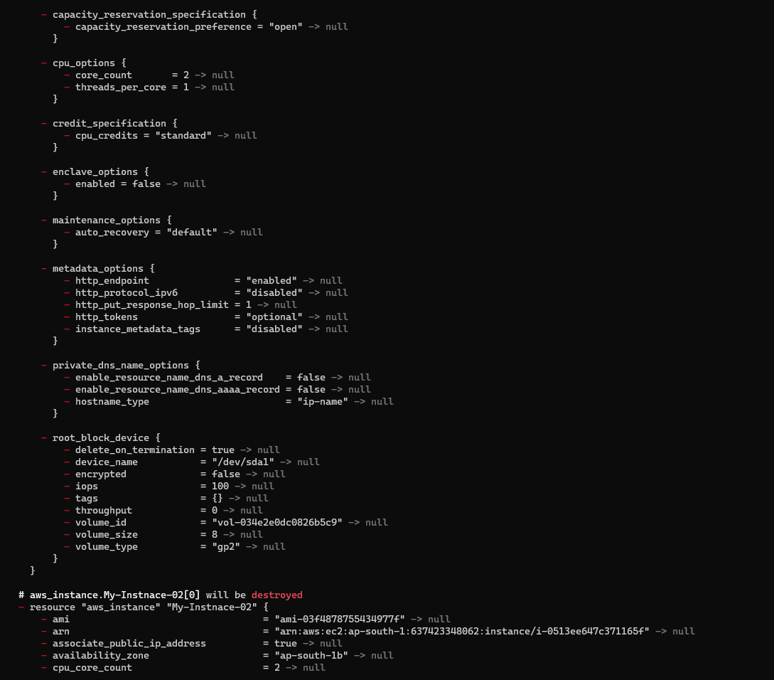

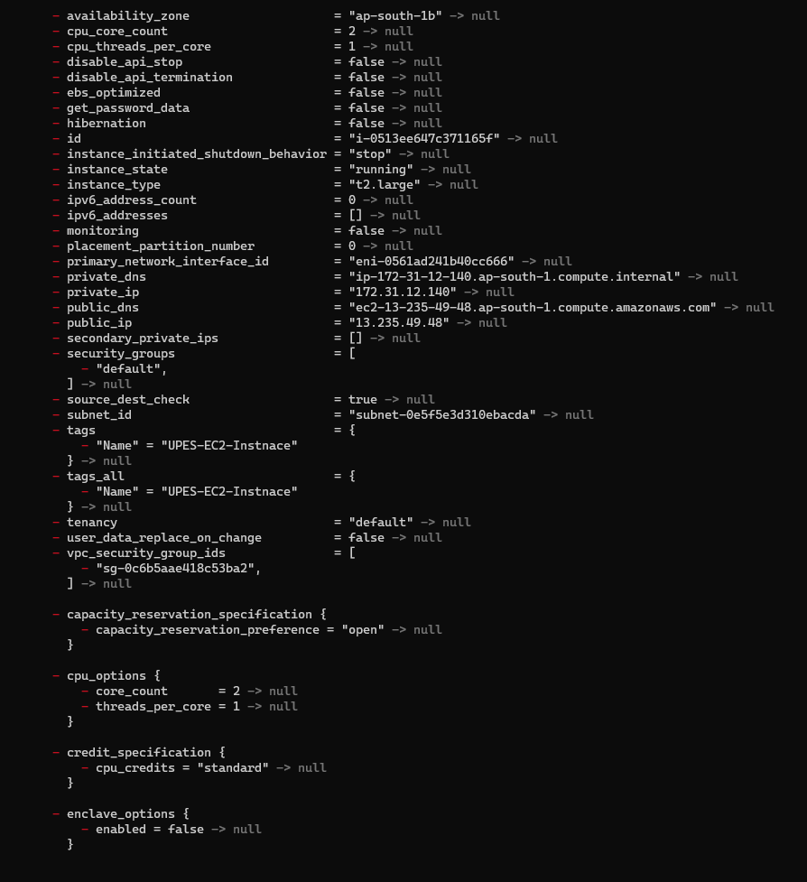

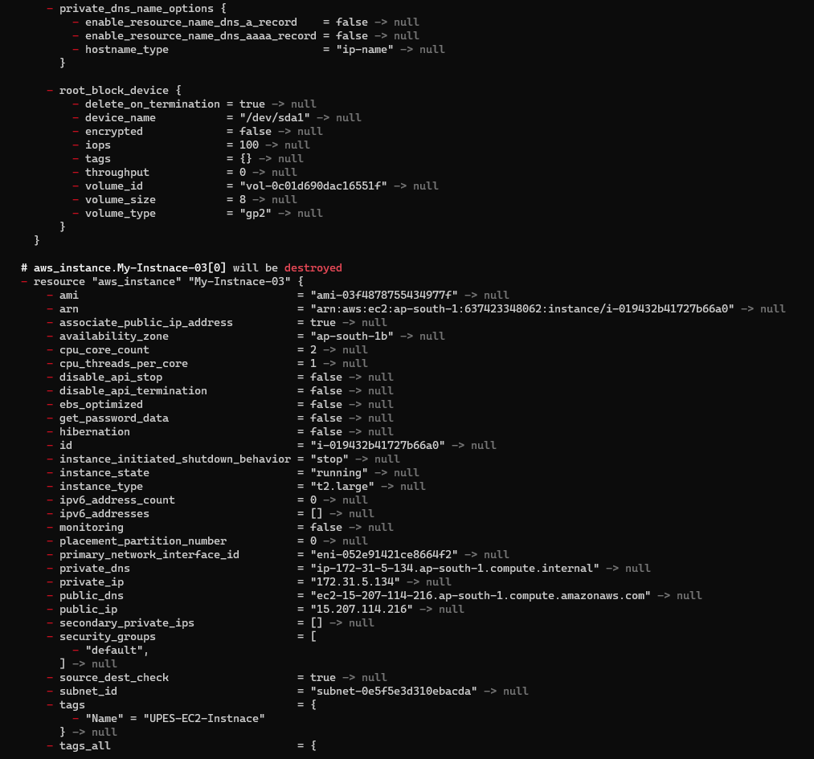

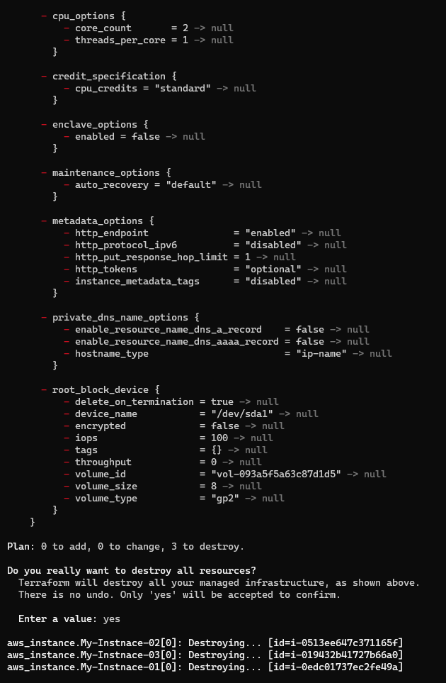

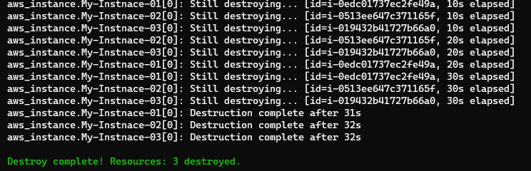

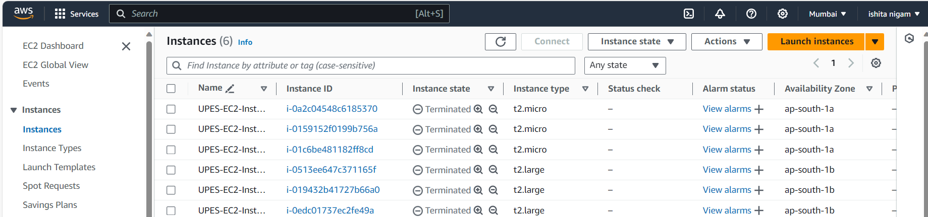

**LAB EXERCISE 6**

**Aim:** Terraform Multiple tfvars Files Objective:

Step 1: Create a instance.tf file

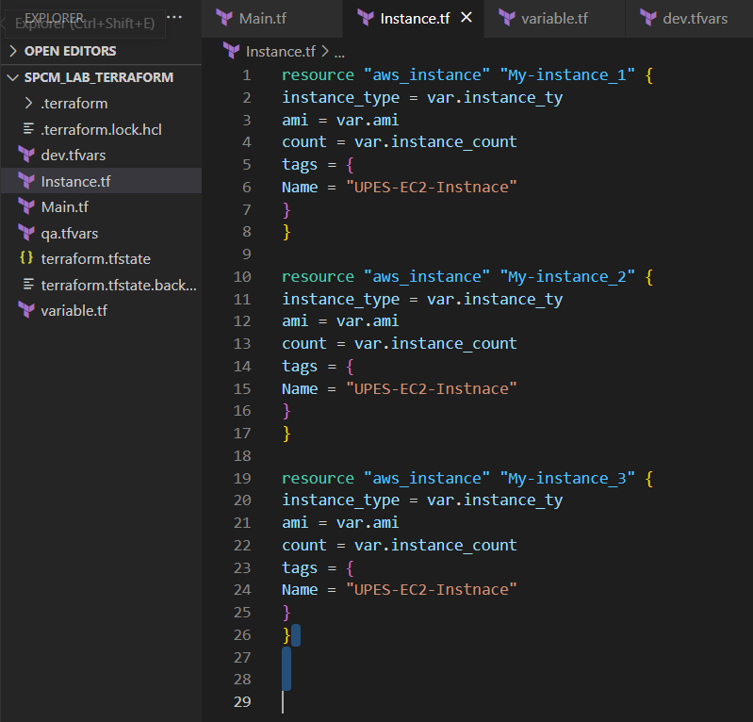

Step 2: Create a variable.tf file

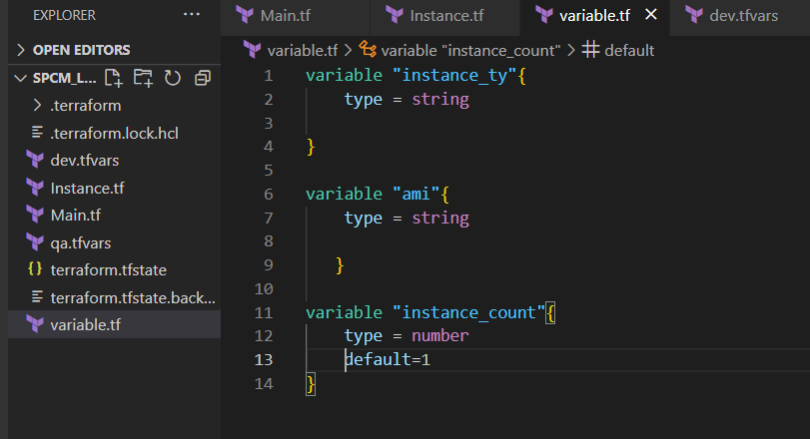

Step 3: Create Multiple tfvars Files:

dev.tfvars

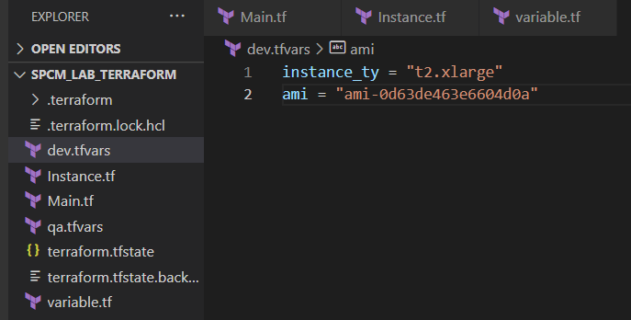

qa.tfvars

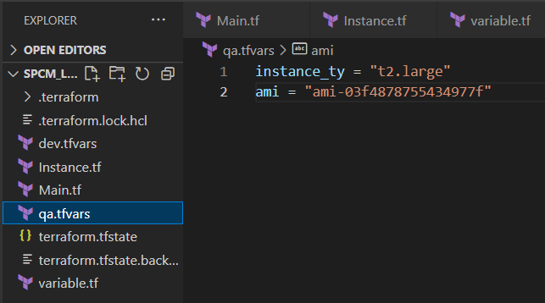

Step 4: Now initializes

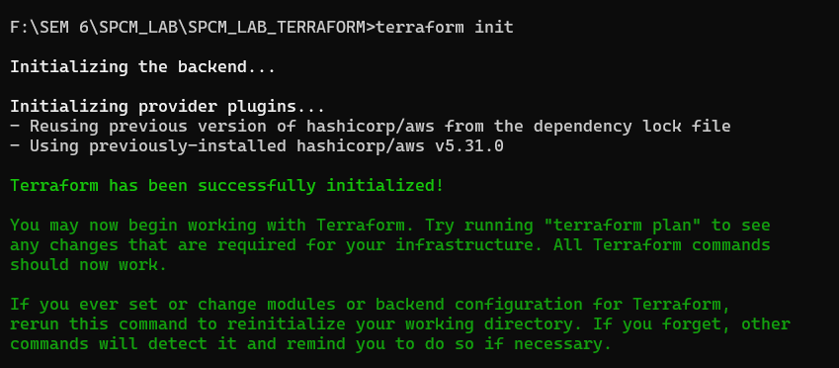

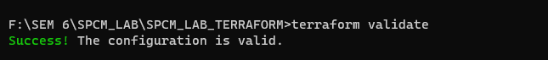

Step 5: Apply for Dev Environment

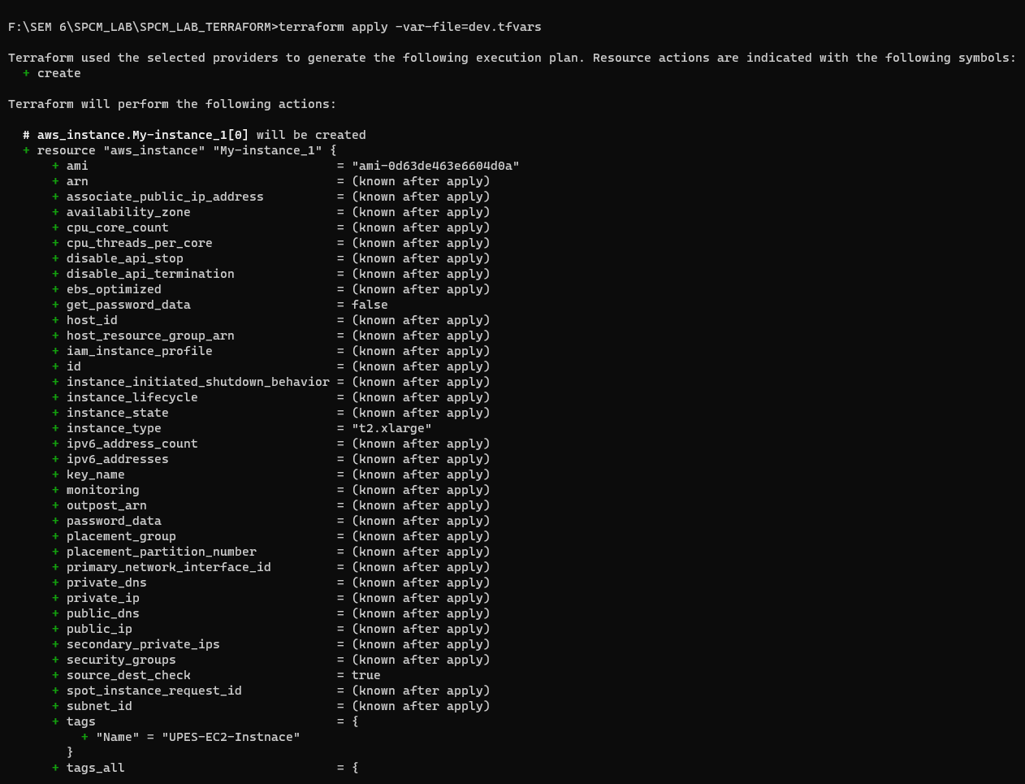

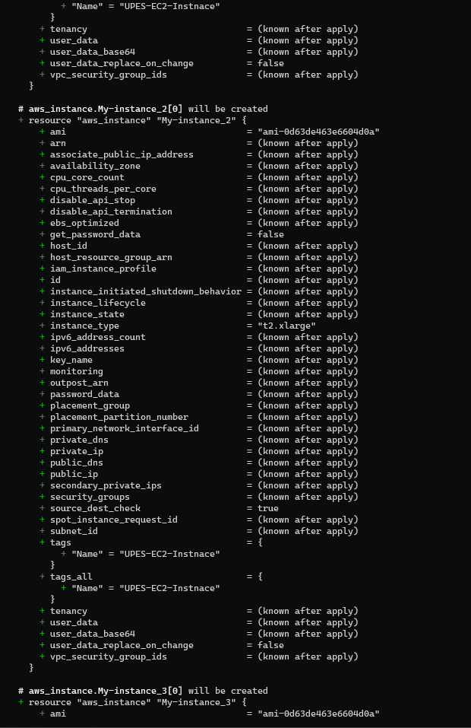



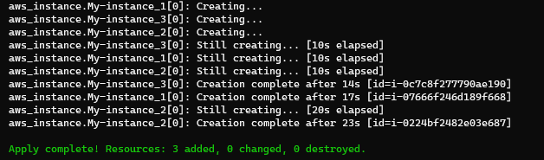

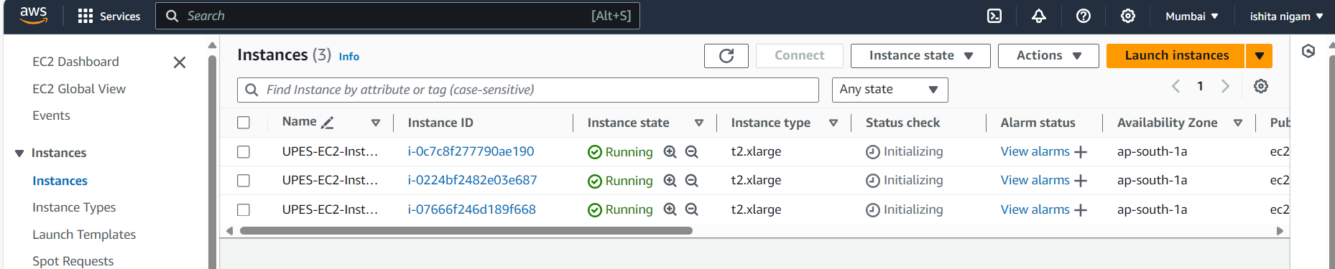

Step 6: Destroy Dev Environment

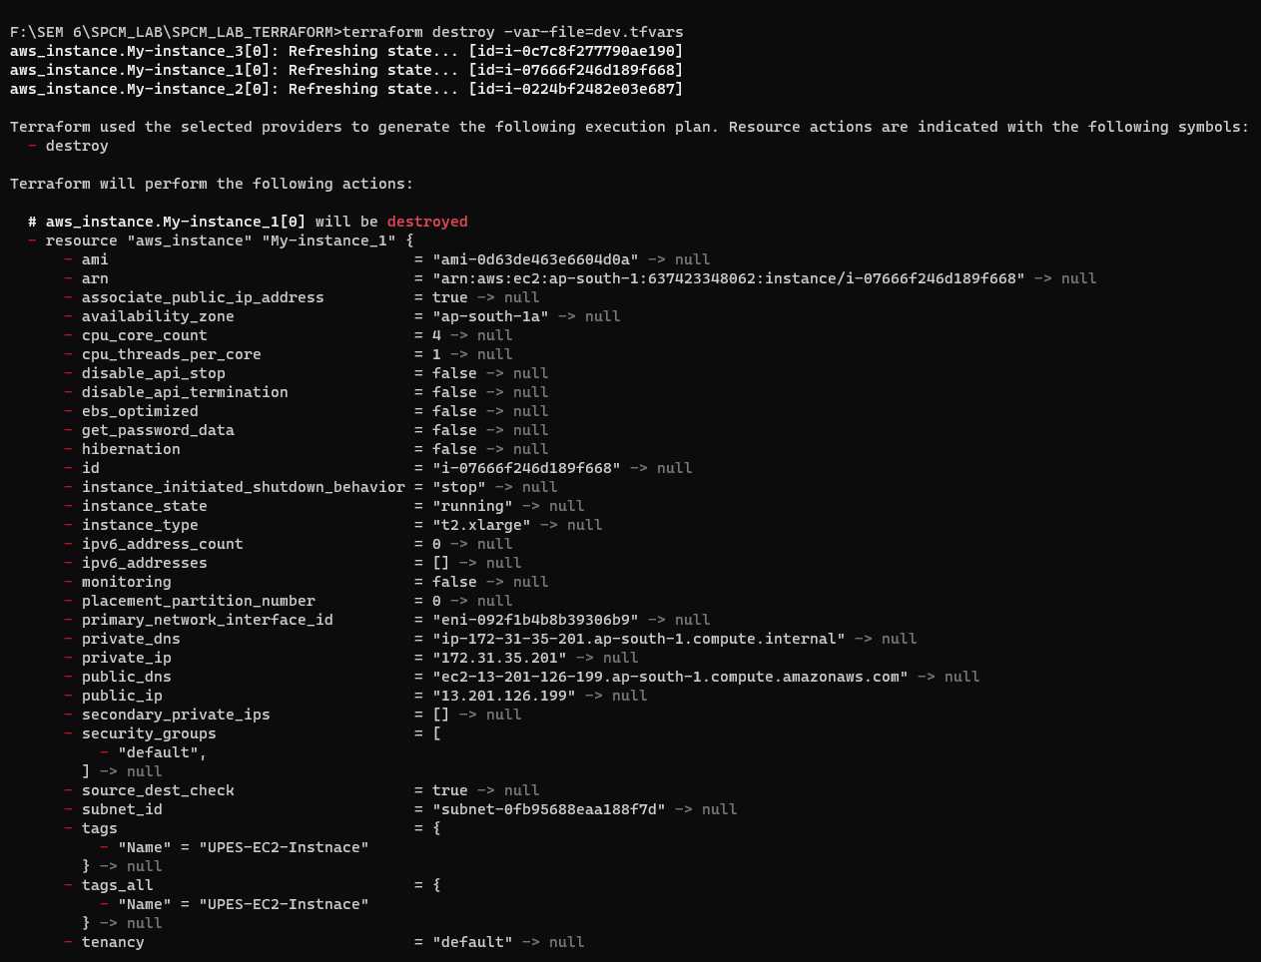

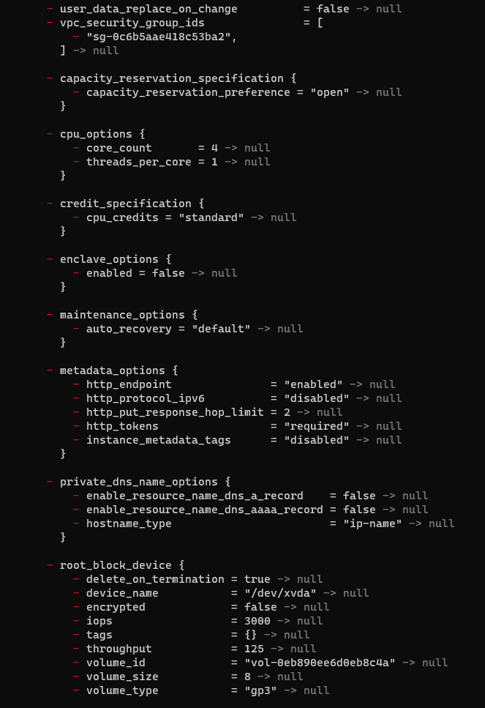

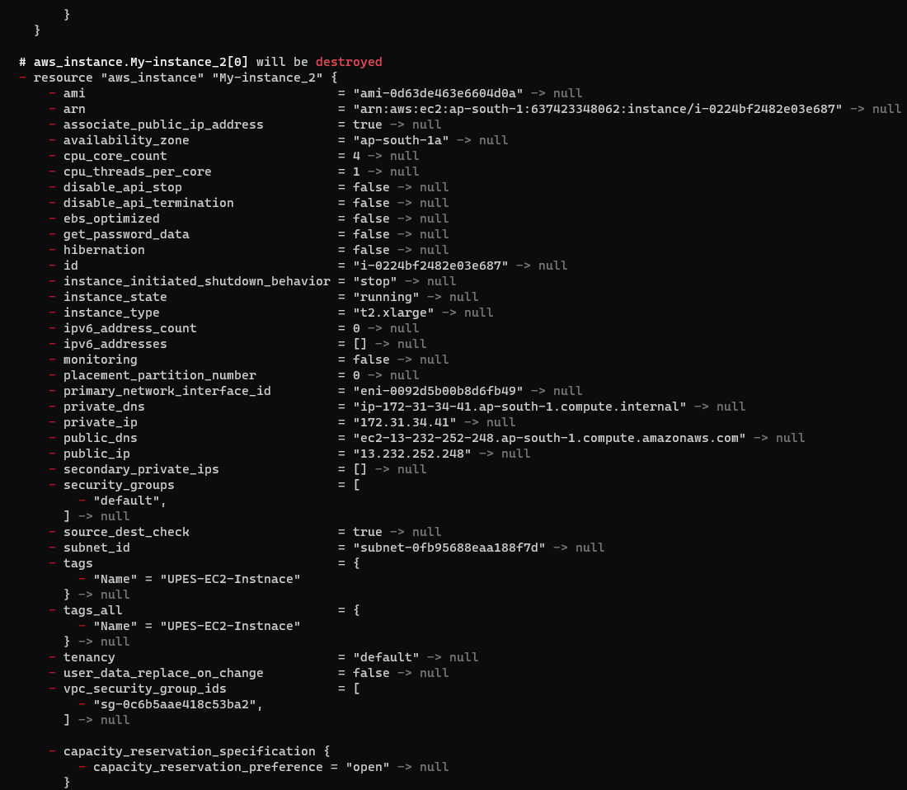

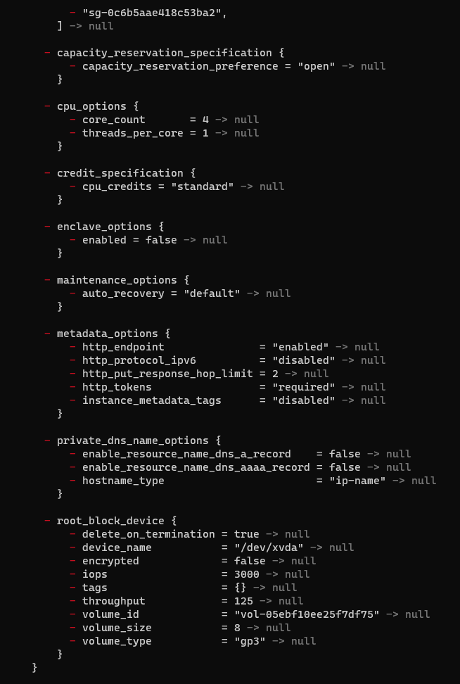

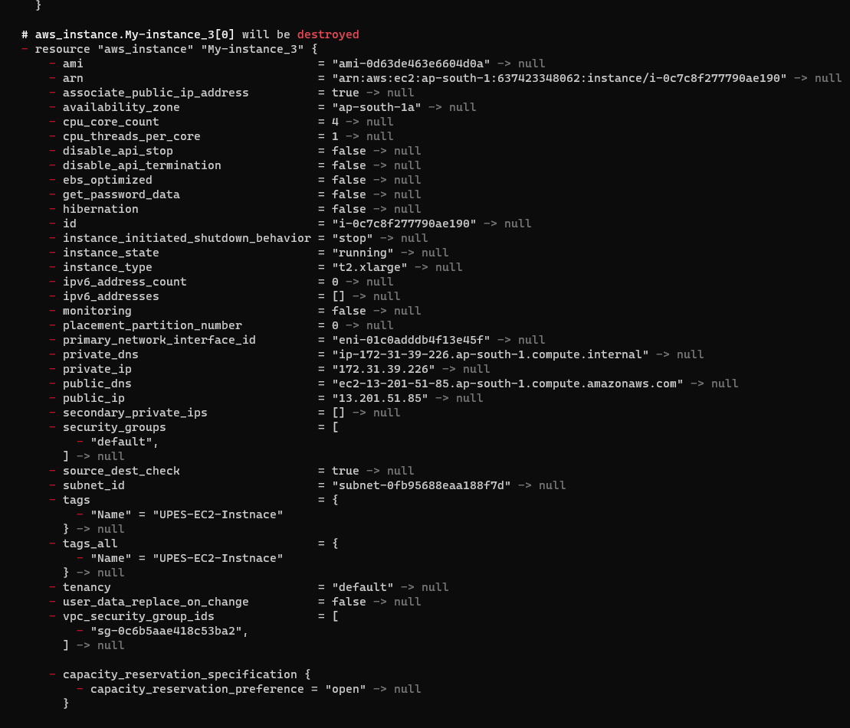

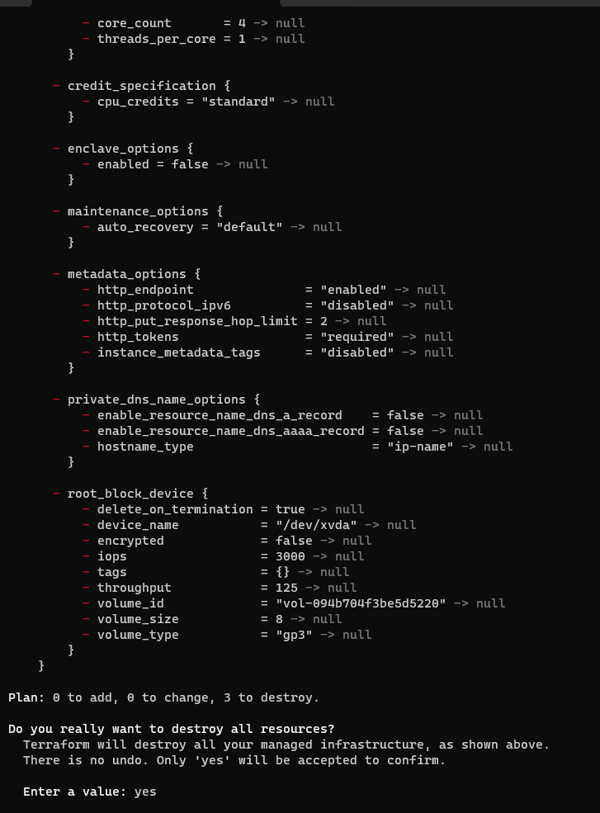

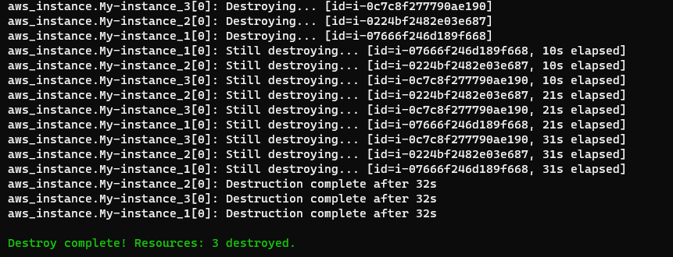

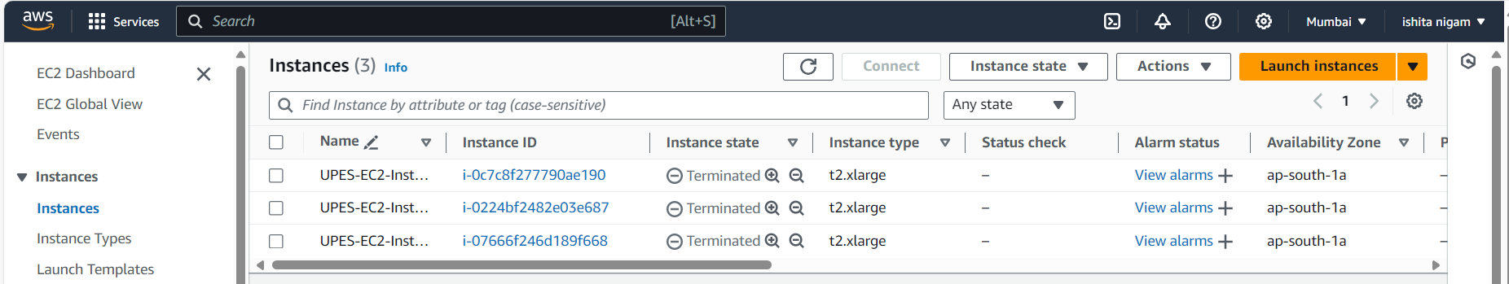

Step :- Apply for Qa Environment

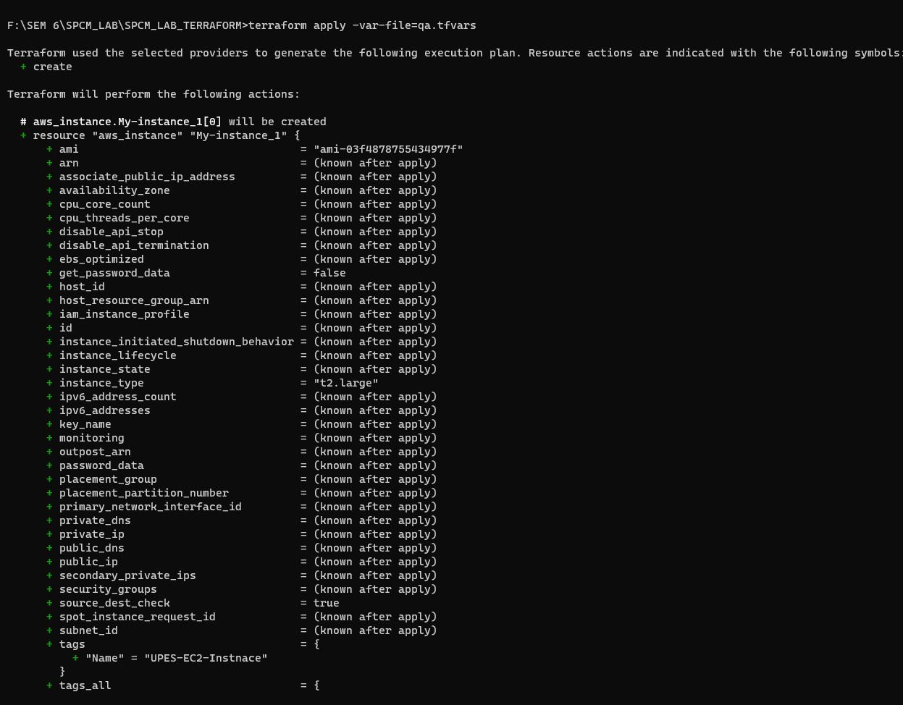

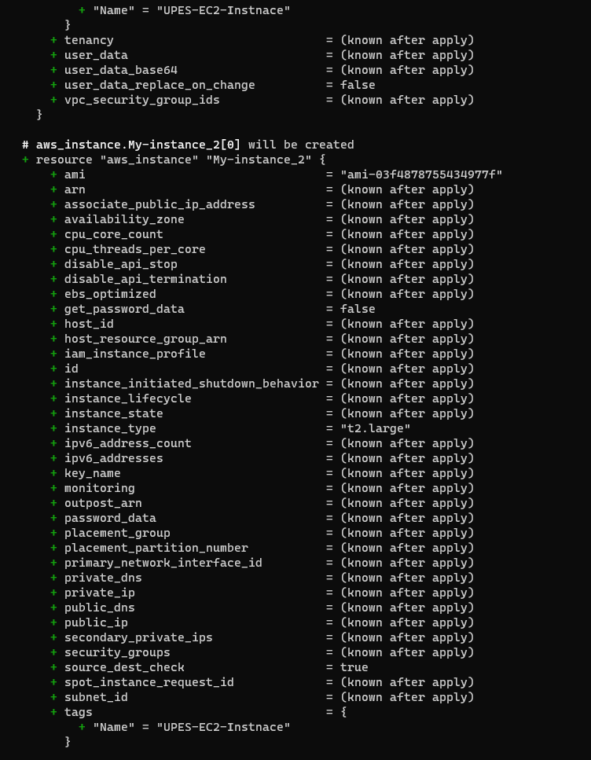

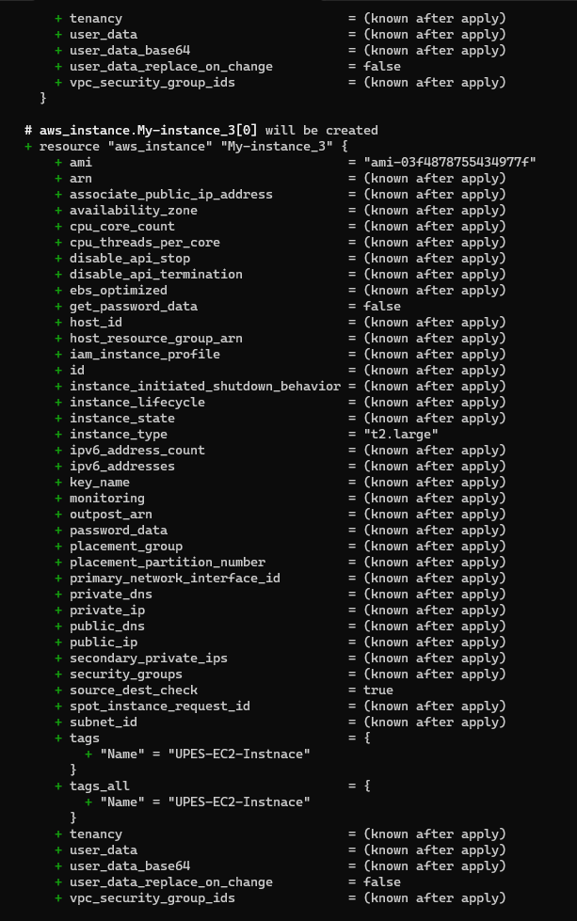

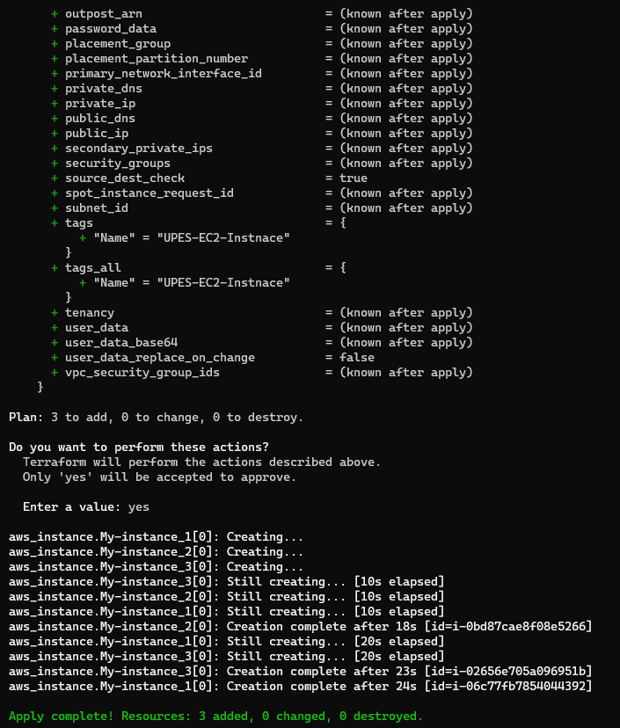

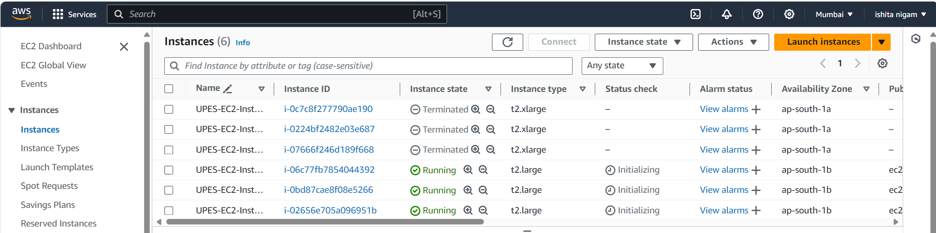

Step 8: Destroy for Qa Environment

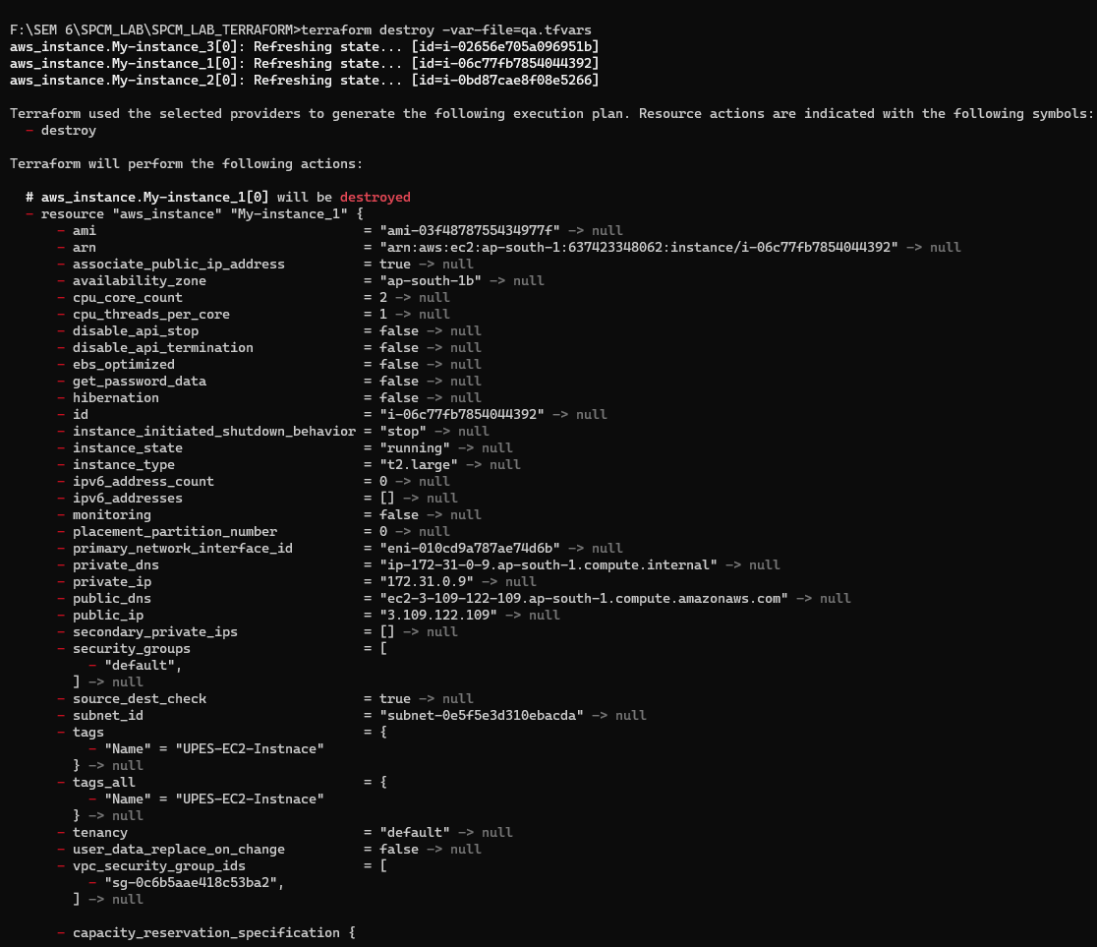

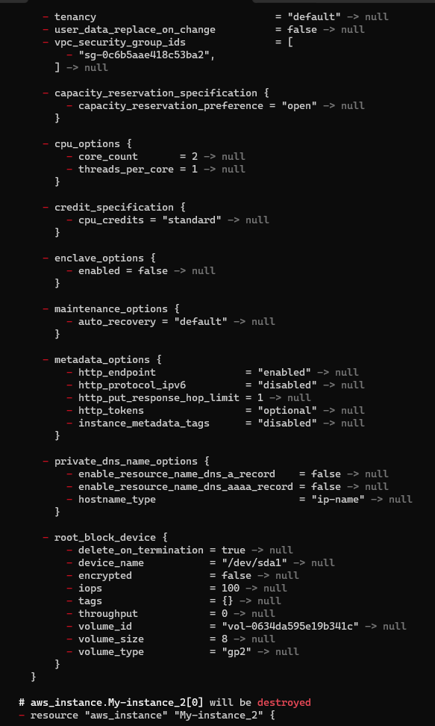

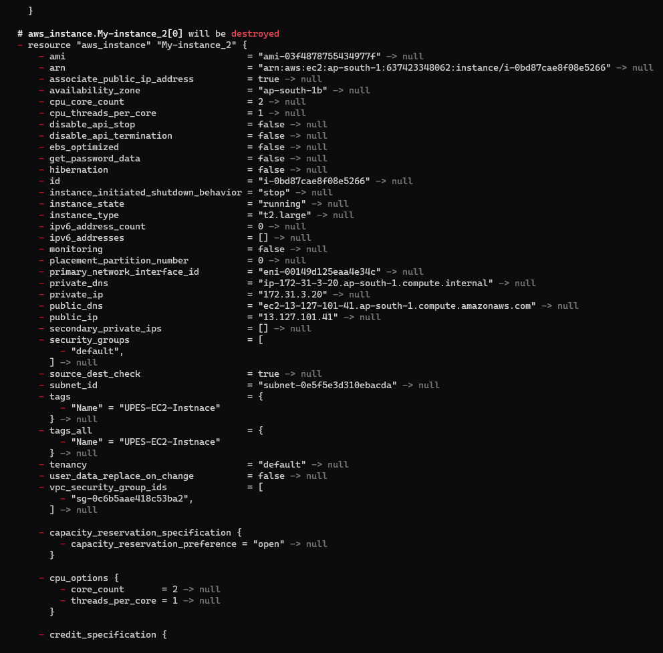

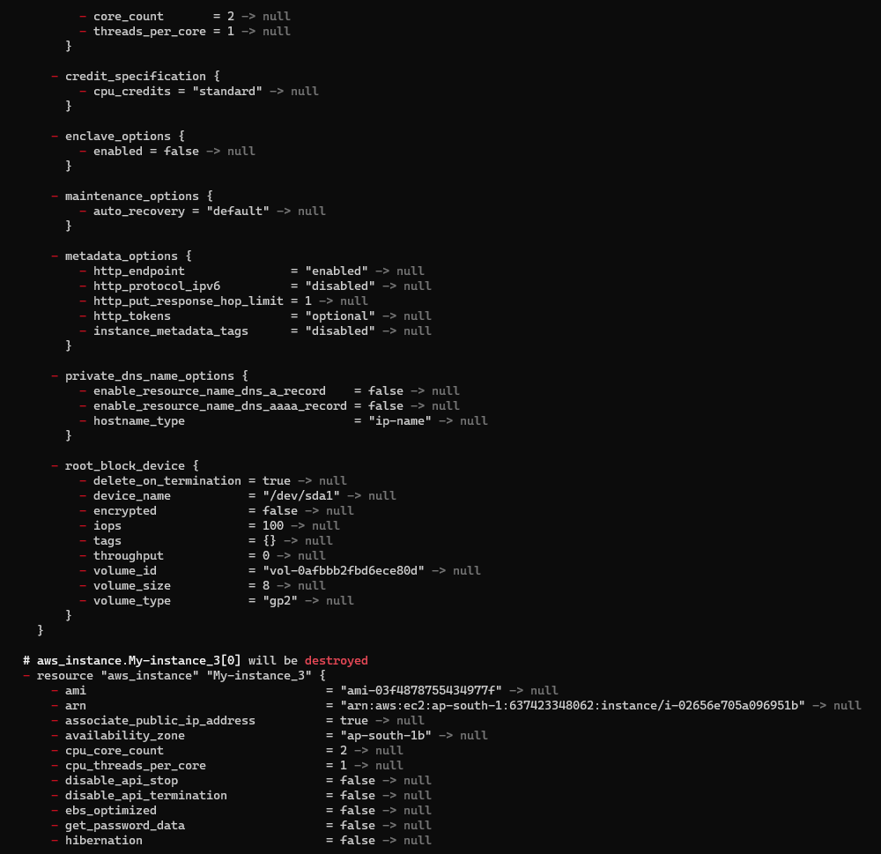

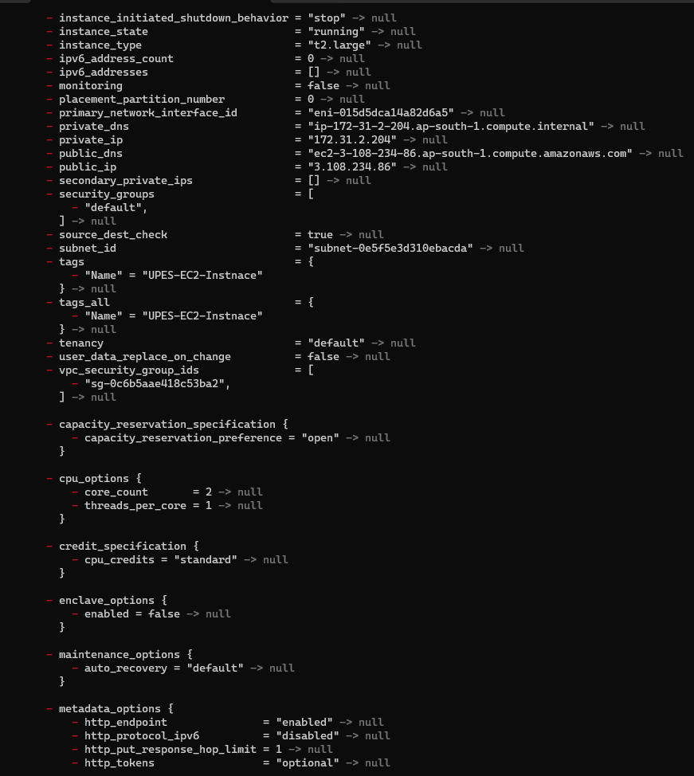

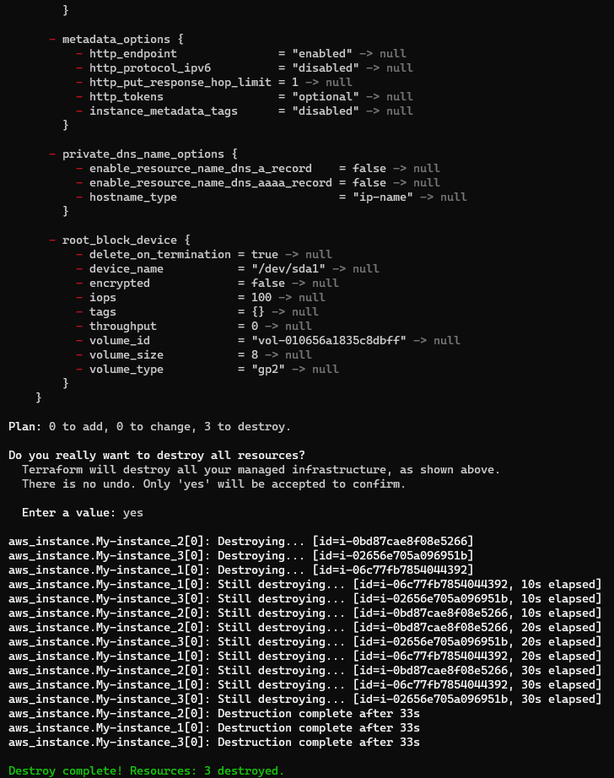

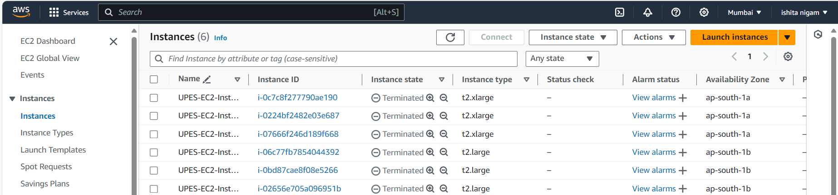

.

**LAB EXERCISE 7**

**Aim:** Creating Multiple IAM Users in Terraform

Step 1: Create a main.tf file.

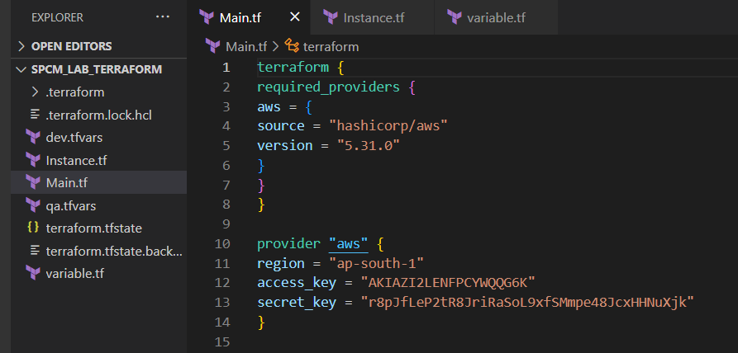

Step 2: Create a instance.tf file

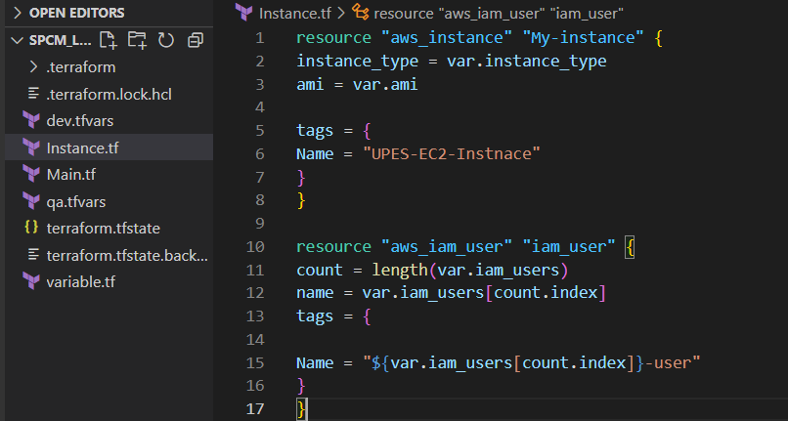

Step 3: Create a variable.tf file

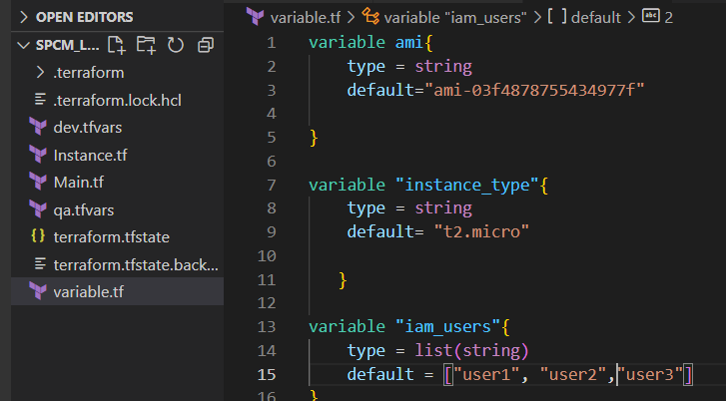

Step 4: Now initializes

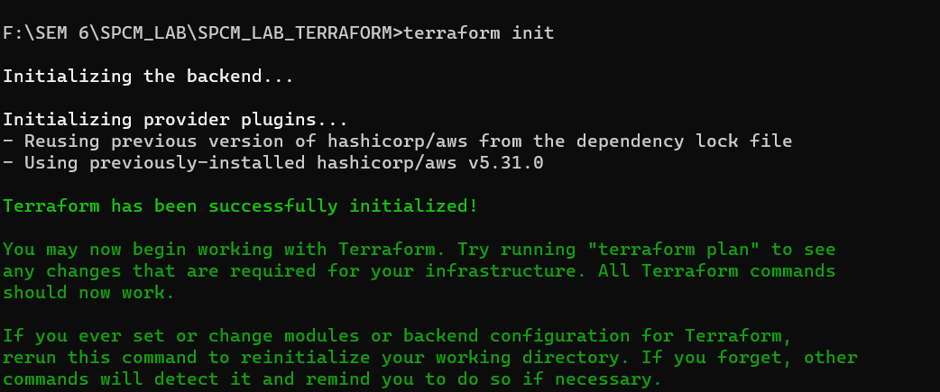

Step 5: Now perform validate

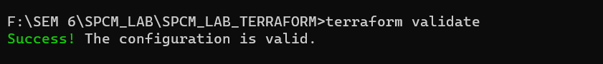

Step 6: Now perform the terraform apply

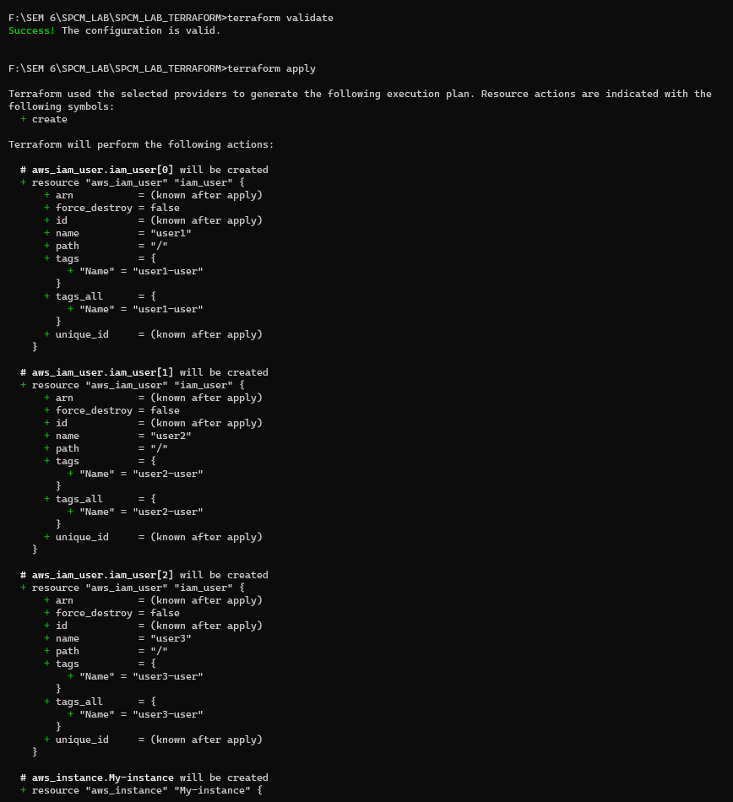

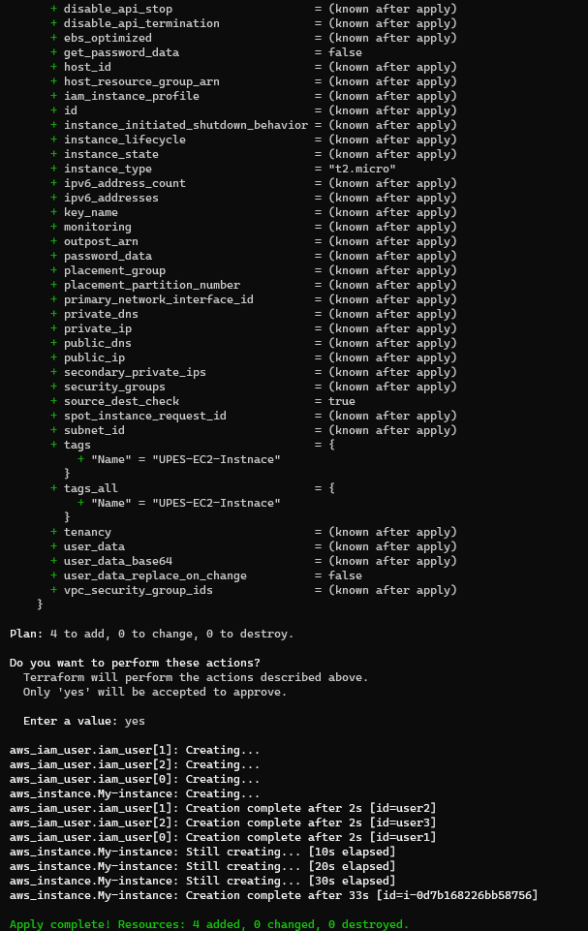

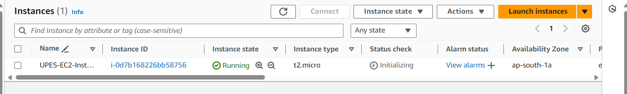

Step 7: Now perform Terraform destroy

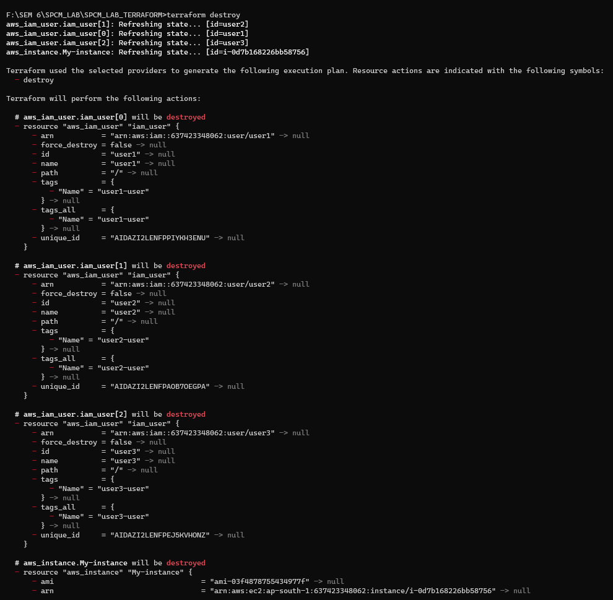

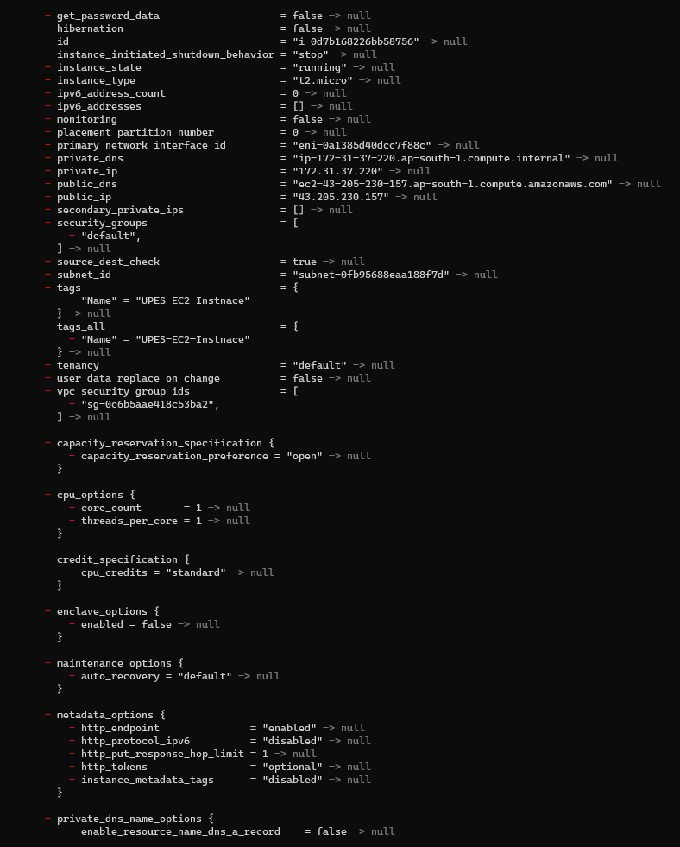

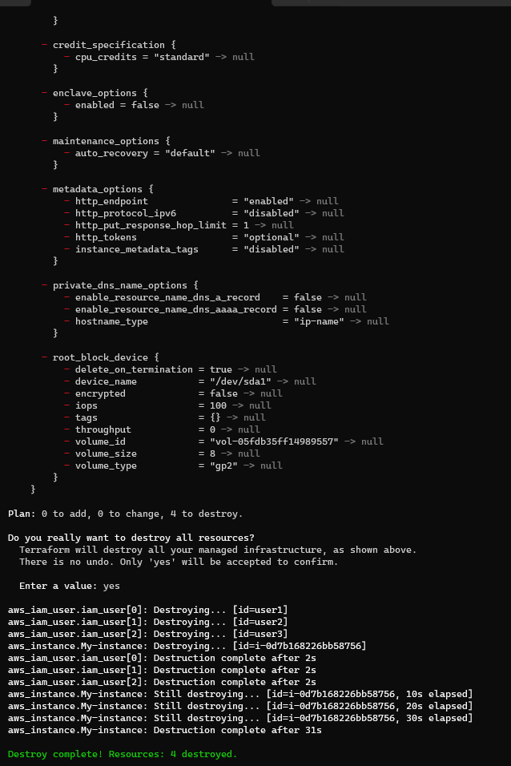

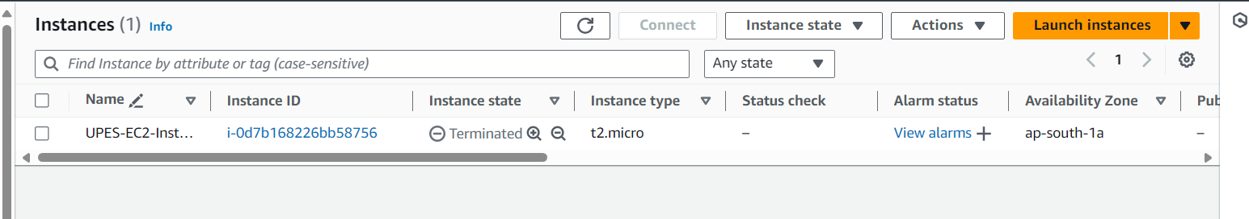

**LAB EXERCISE 8**

**Aim: Creating a VPC in Terraform Objective**

Step 1: Create a main.tf file

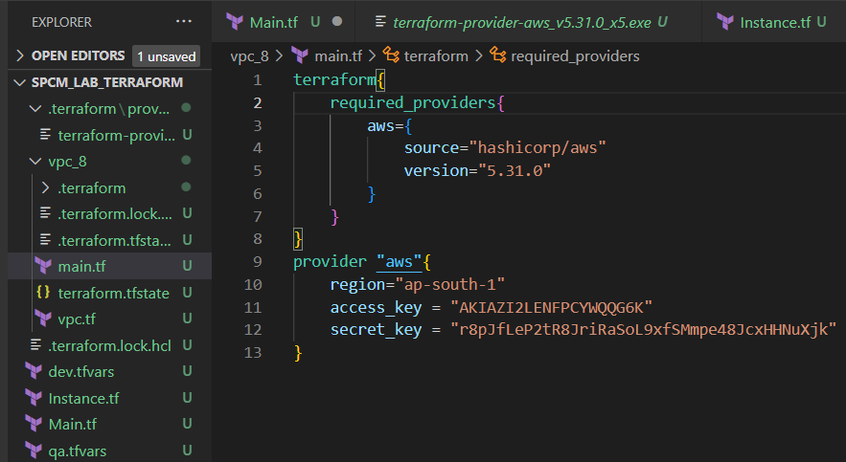

Step 2: Create a vpc.tf file

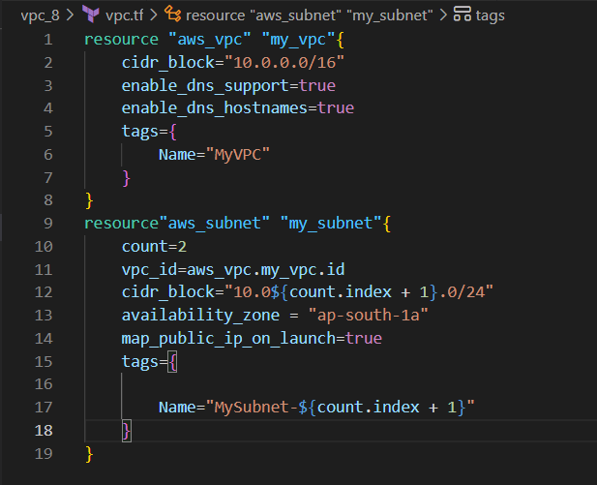

Step 3: Now run terraform init command to Initialize.

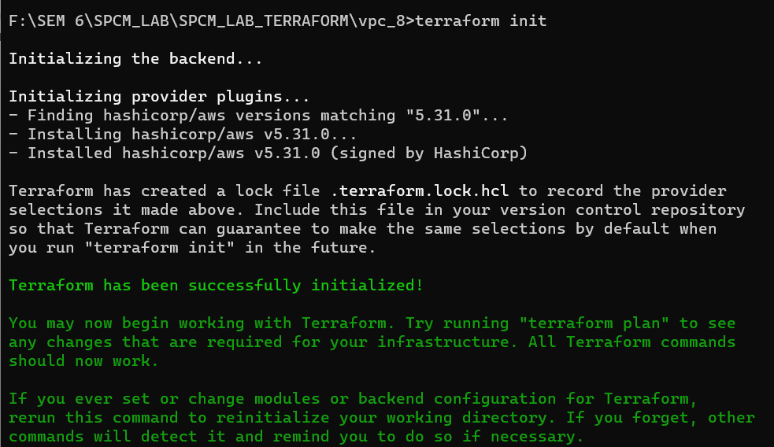

Step 4: Now run the terraform validate command to check if any error is present or not.

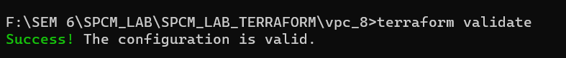

Step 5: Now run terraform plan command

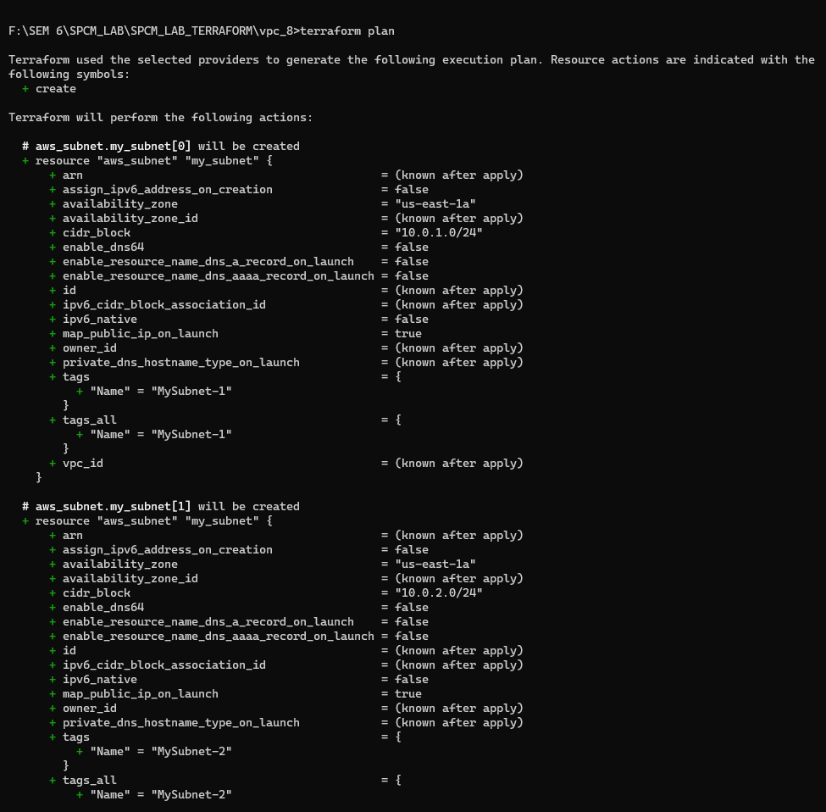

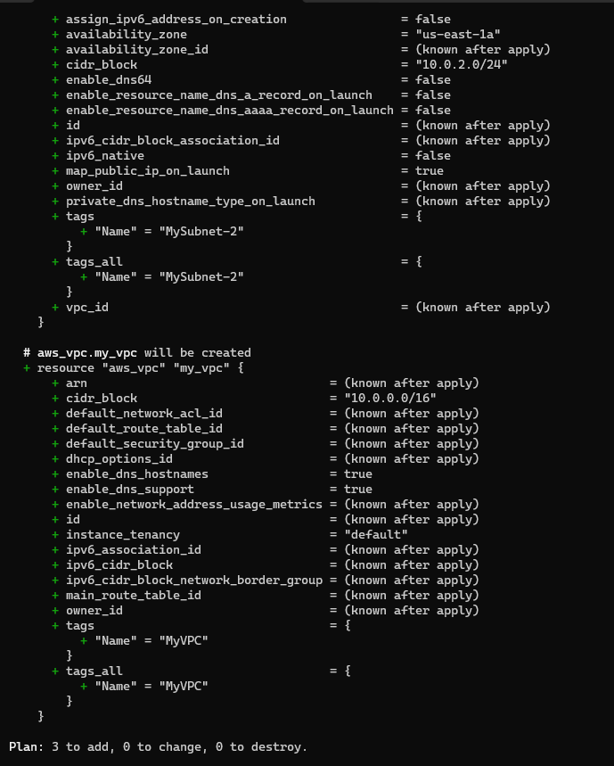

Step 6: Now run the terraform apply command.

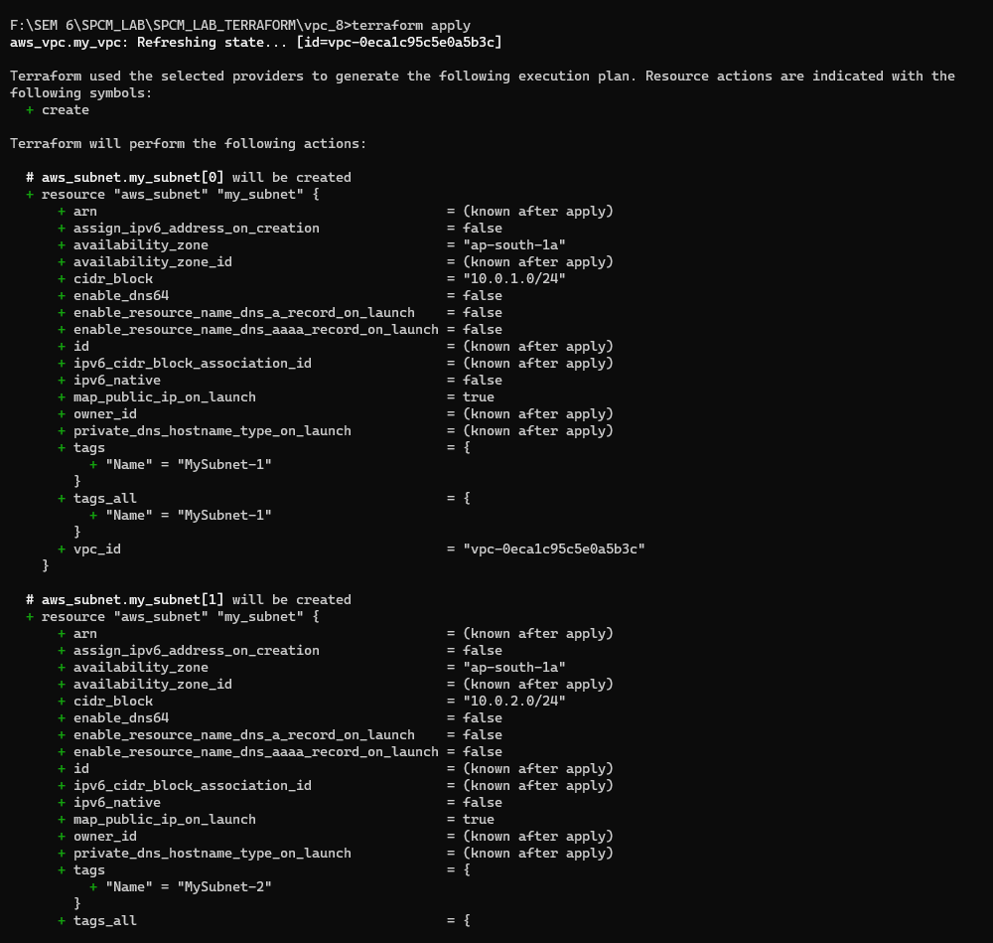

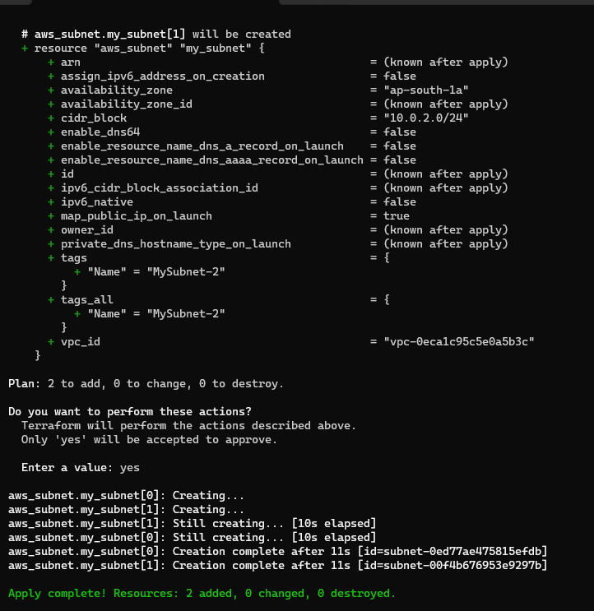

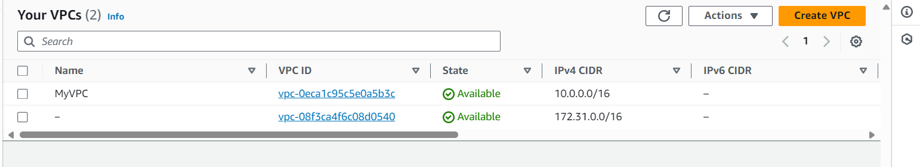

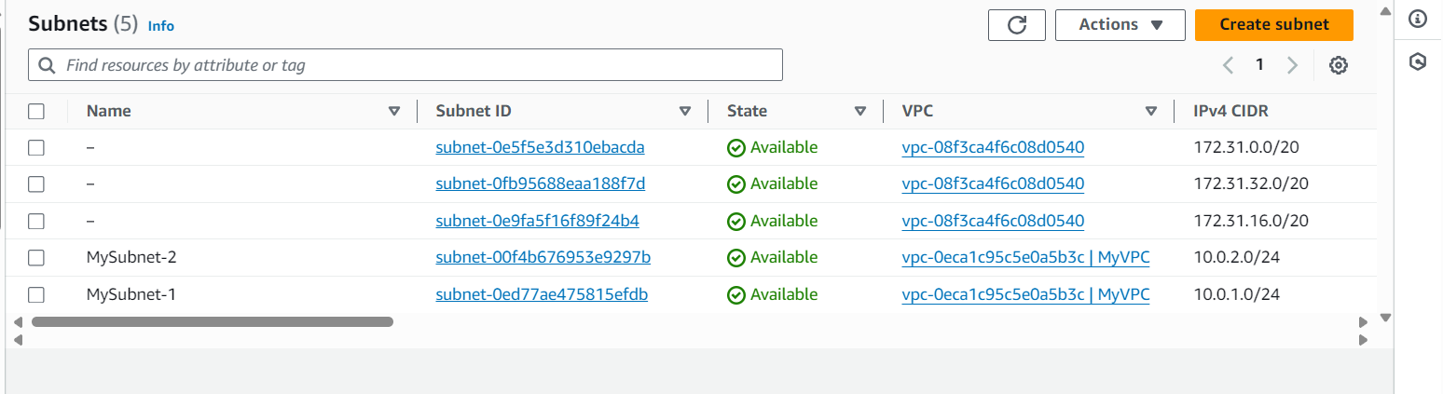

Step 7: Now run the terraform destroy to destroy the VPC created.

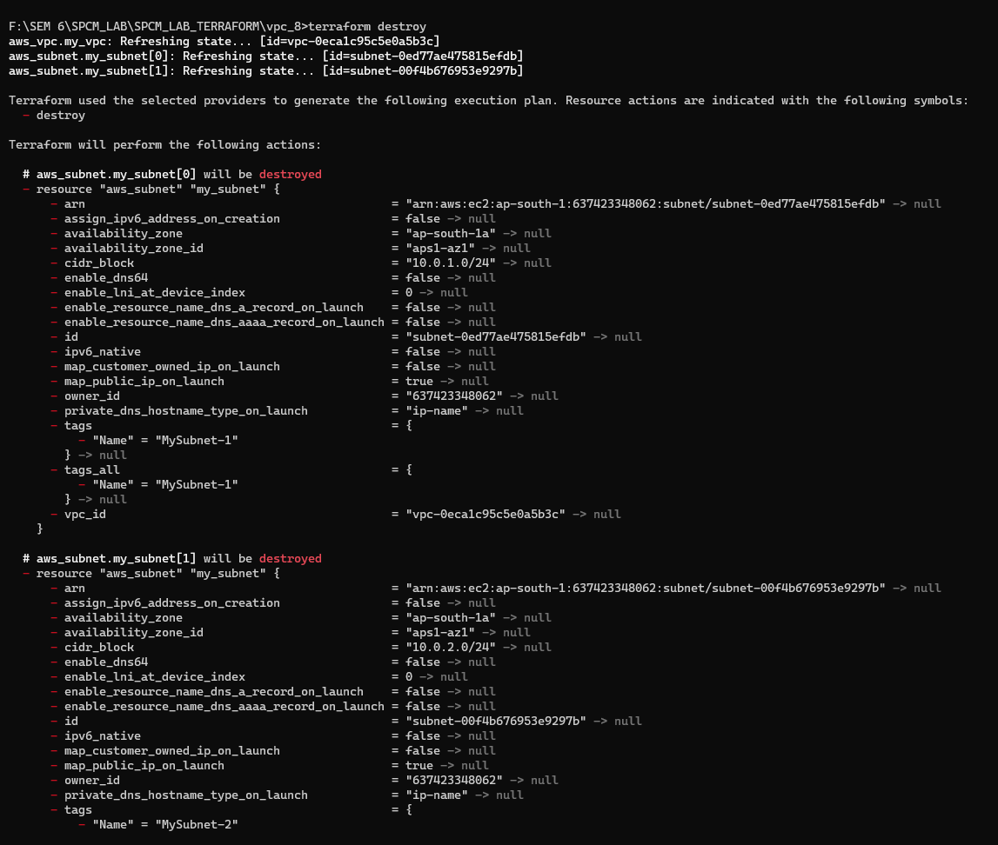

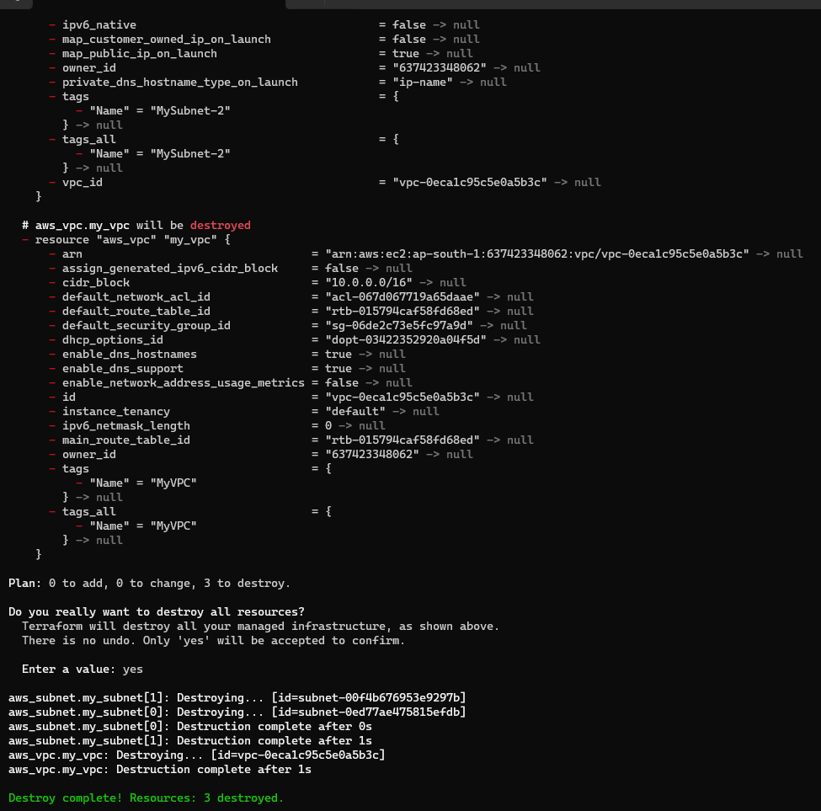

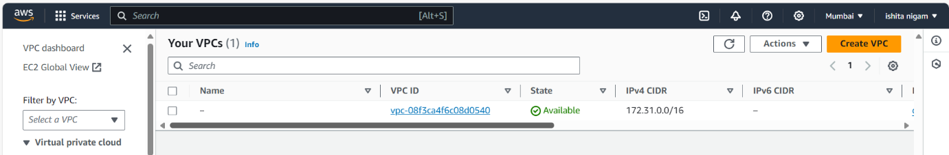

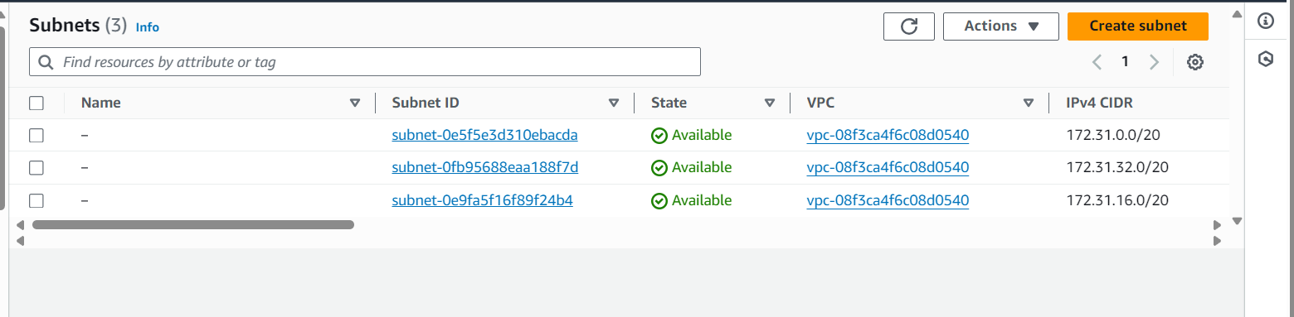

Step 8: Now update the vpc.tf file.

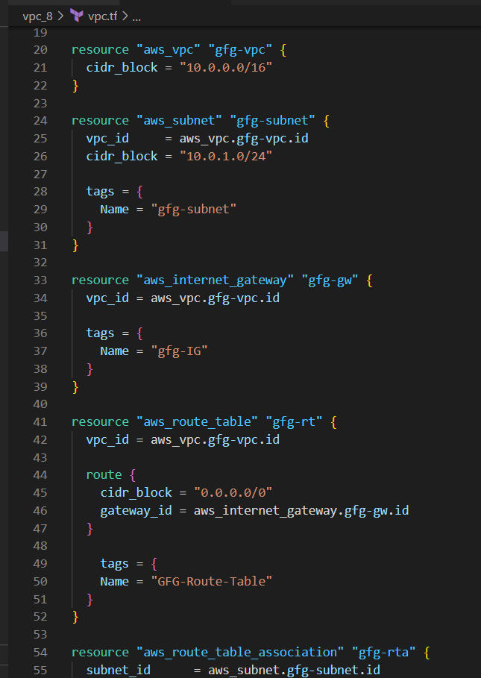

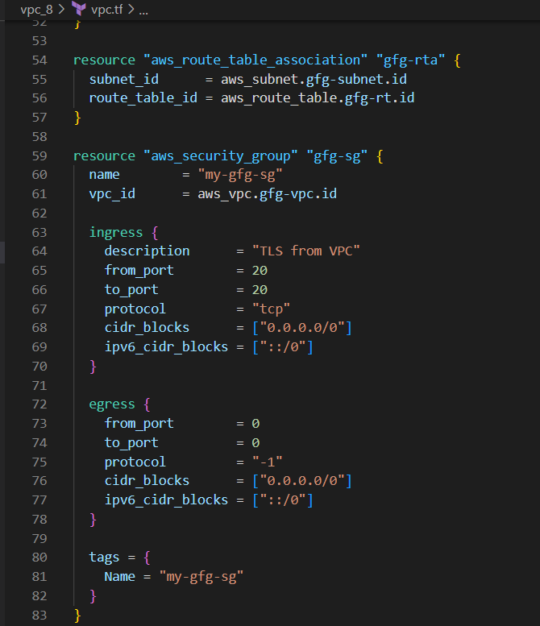

Step 9: Now again run the terraform run and validate command.

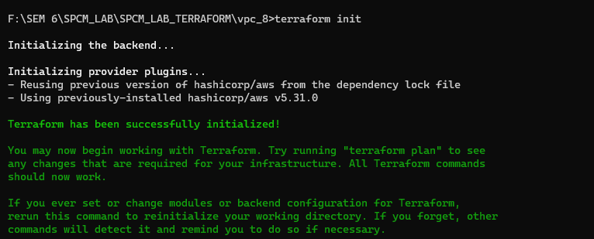



Step 10: Now again run the terraform plan command.

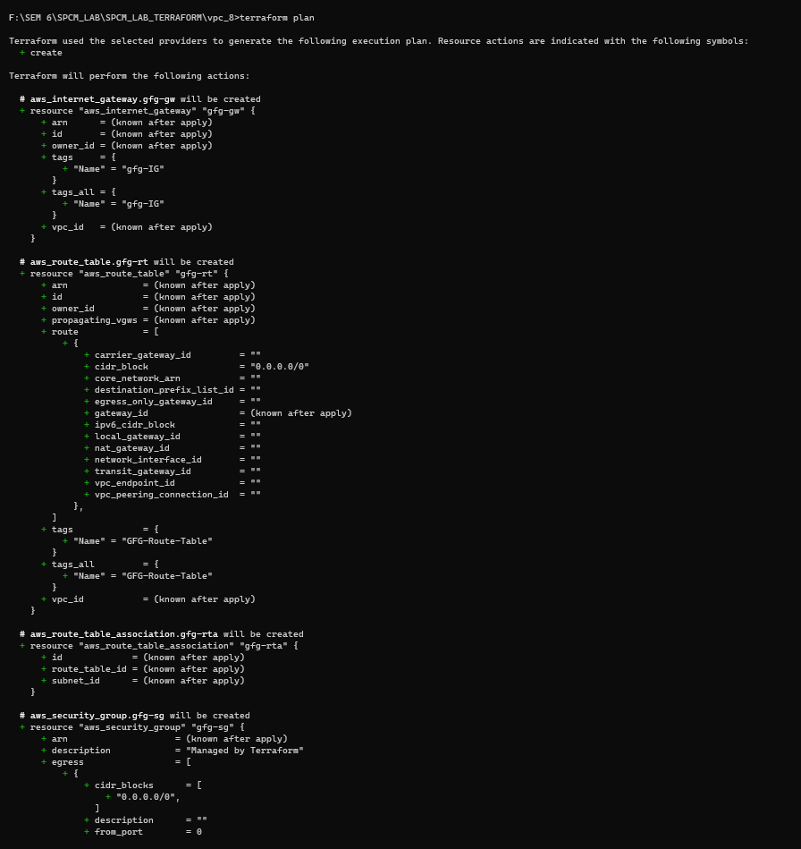

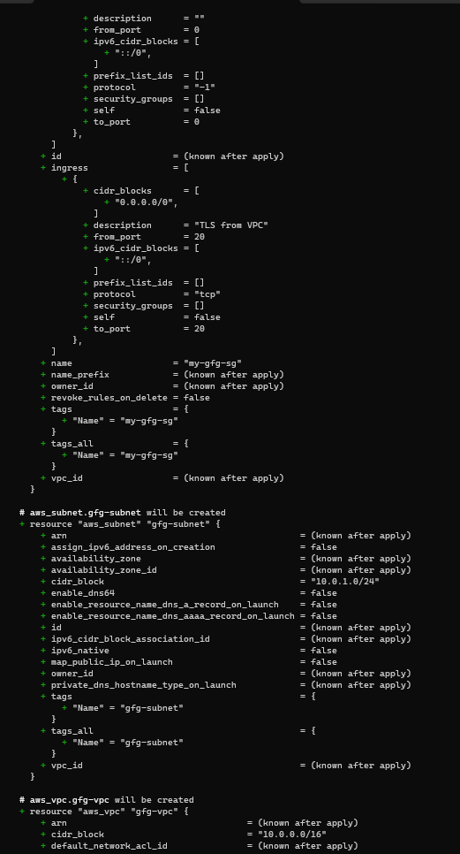

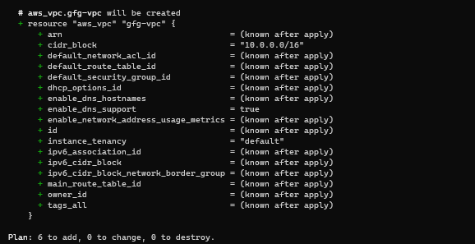

Step 11: Now run the terraform apply command.

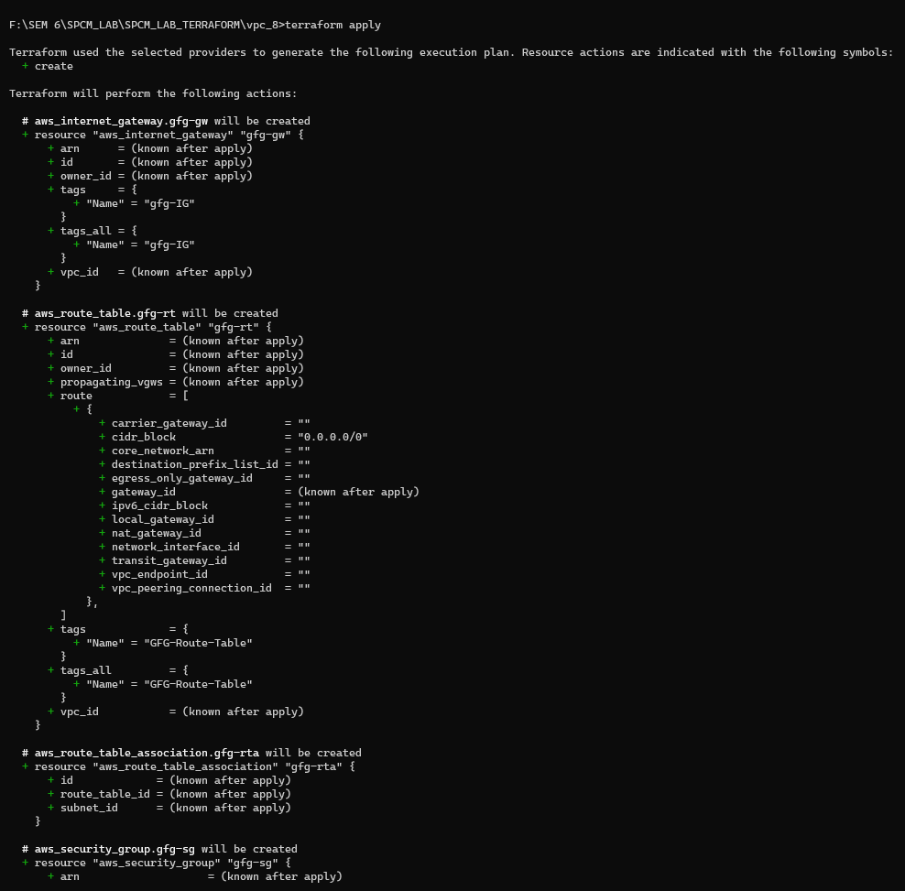

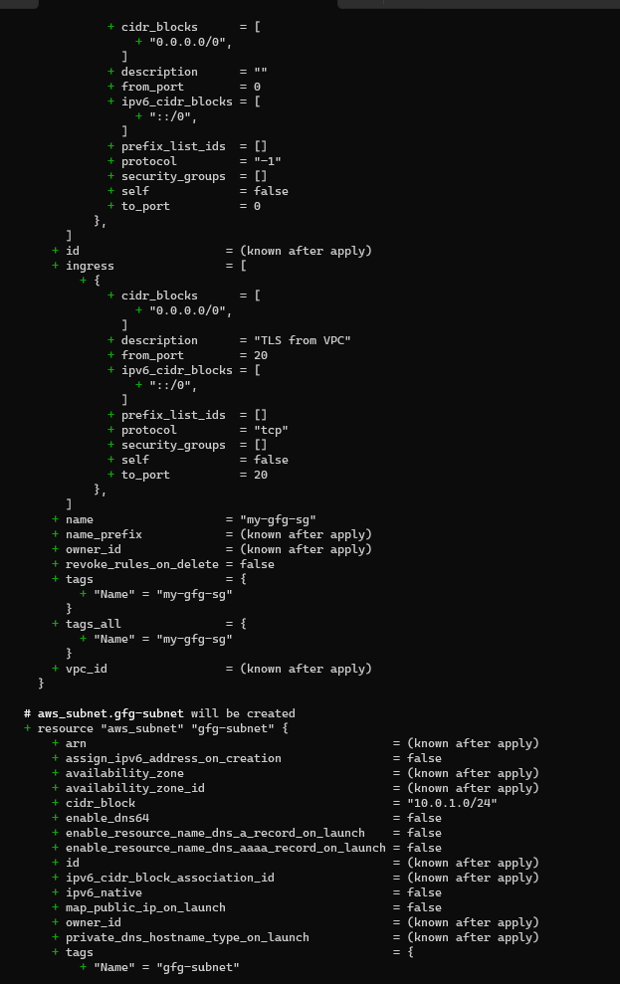

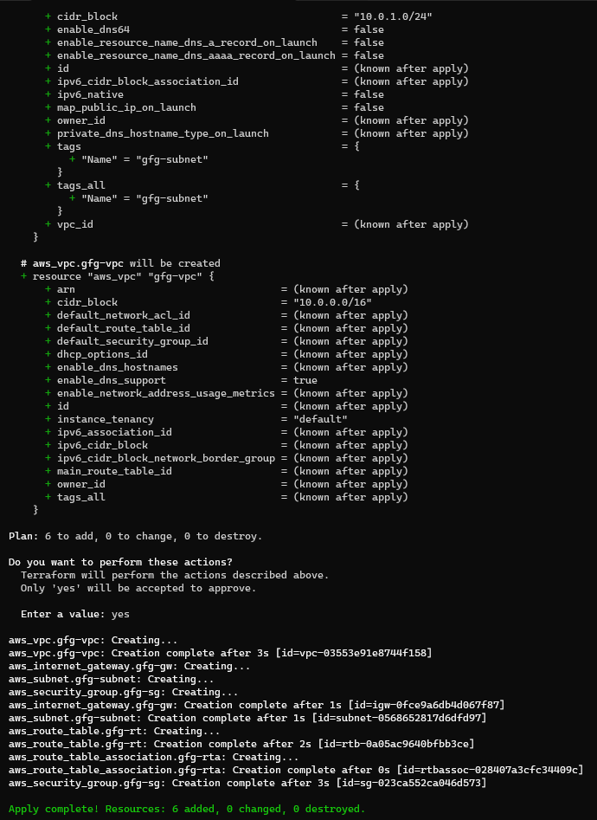

VPC:

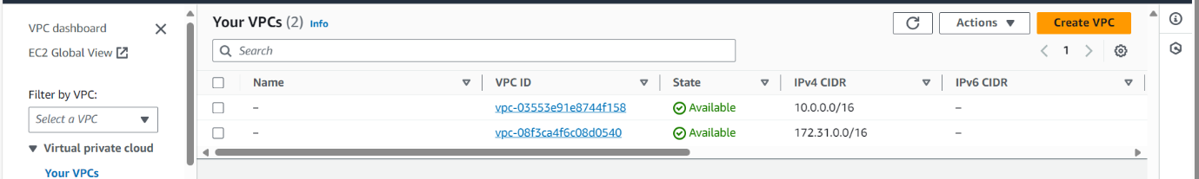

SUBNET:

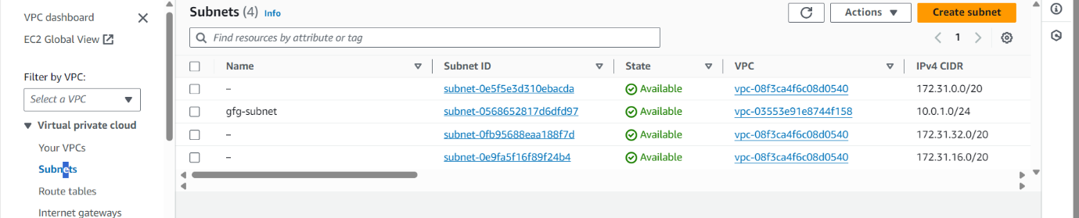

ROUTE TABLE:

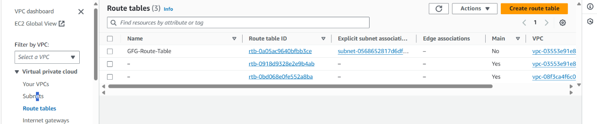

INTERNET GATEWAY:

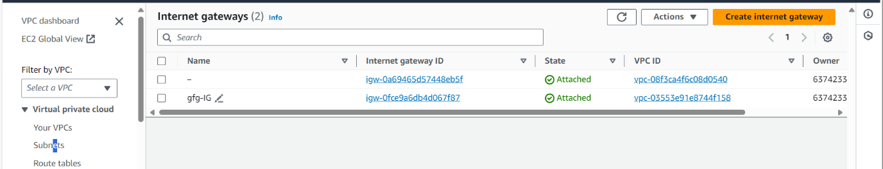

Step 12: Now run terraform destroy command.

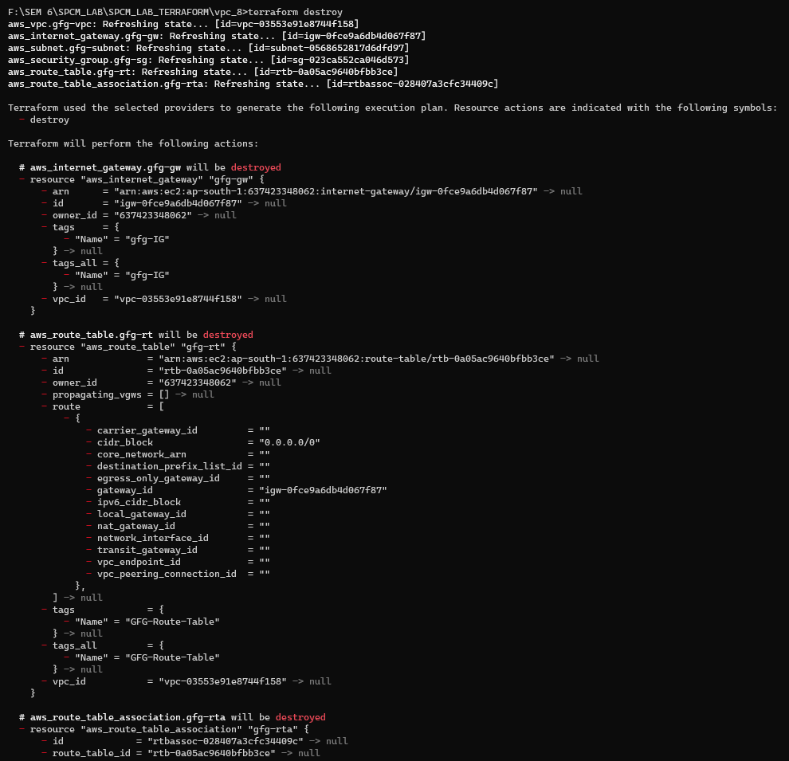

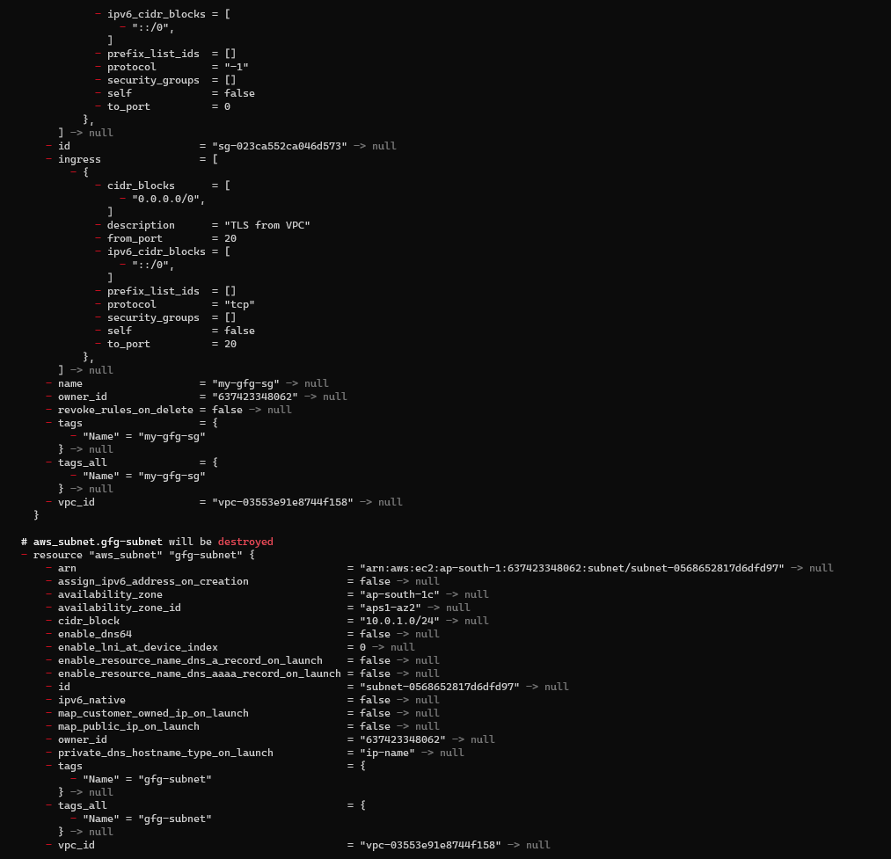

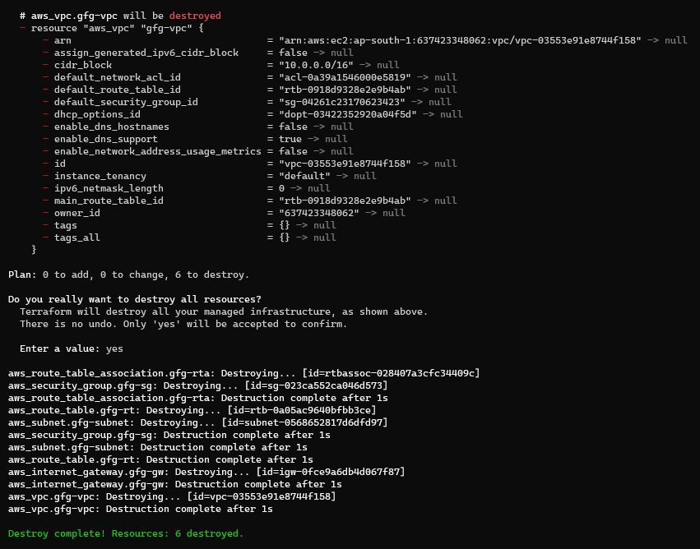

VPC:

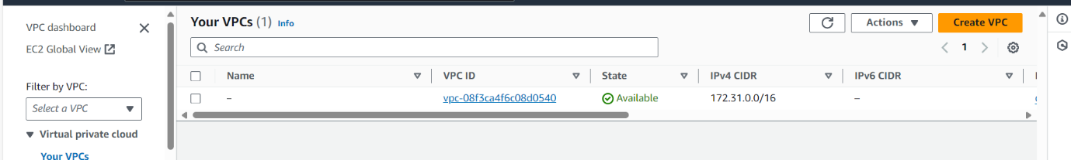

SUBNET:

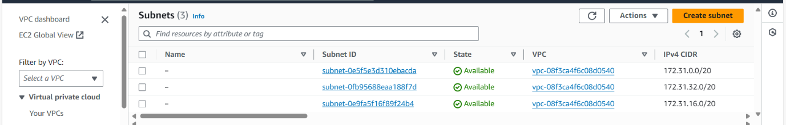

ROUTE TABLE:

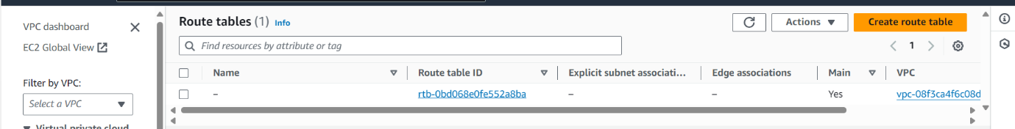

INTERNET GATEWAY:

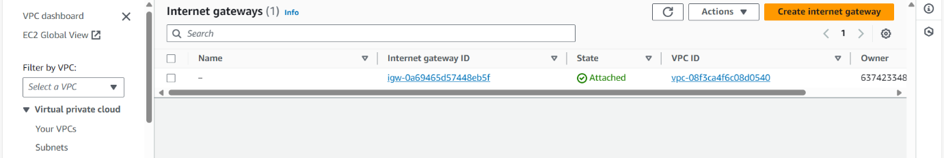

**Experiment 10**

**Creating AWS RDS Instance**

**Steps**

1. Create a main.tf file

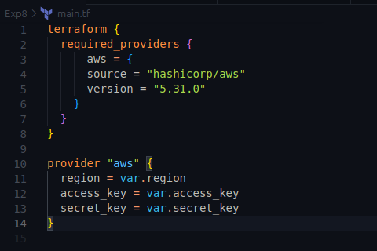

2. Create db.tf

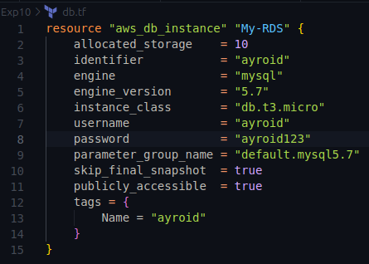

3. Run Terraform init and apply commands

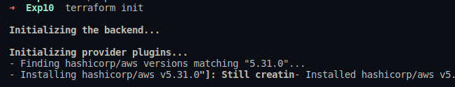

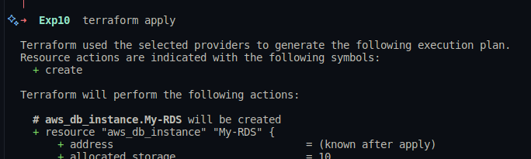

4. Verify resources on AWS

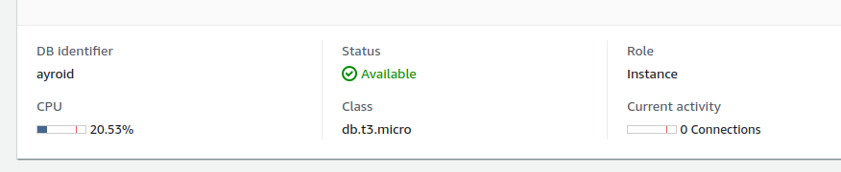

5. Add security groups to access instance from mysql workbench



6. Connect via workbench

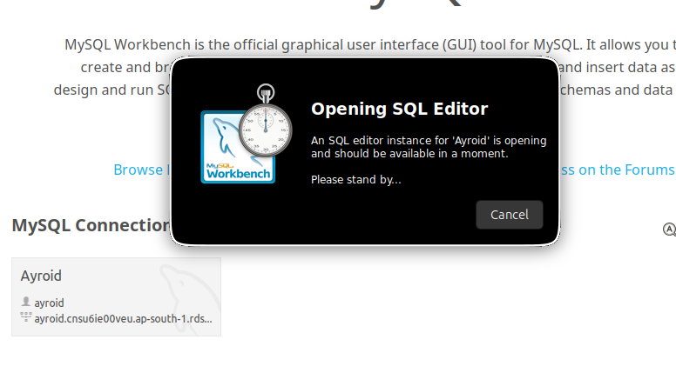

7. Cleanup resources

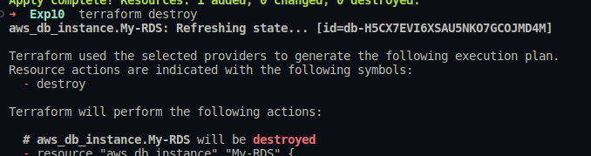

**Experiment 11**

**Configure Ansible Setup In Linux**

**Steps**

1. Create two Amazon Linux t2.micro instance - Ansible Server & Node

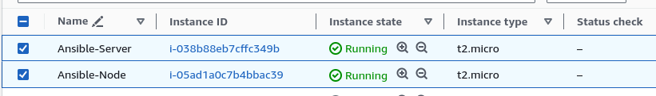

2. Install ansible on Ansible Server

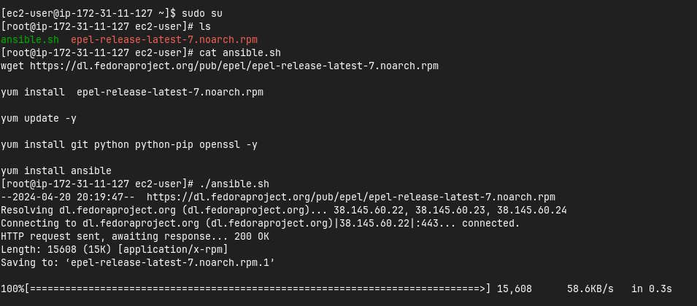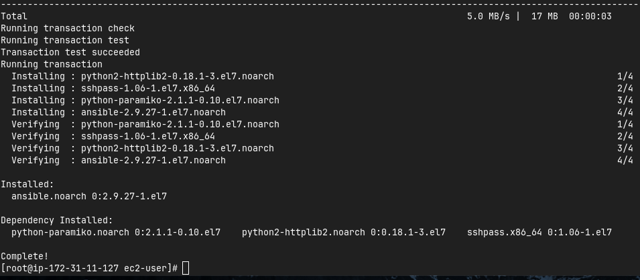

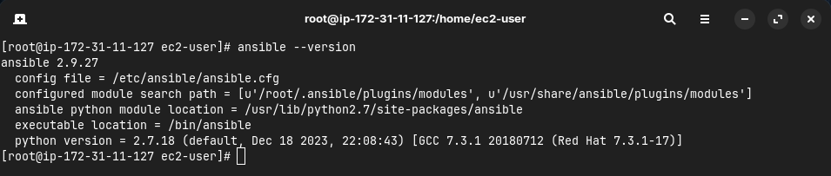

3. Add Private IP of node to the Ansible server’s inventory file

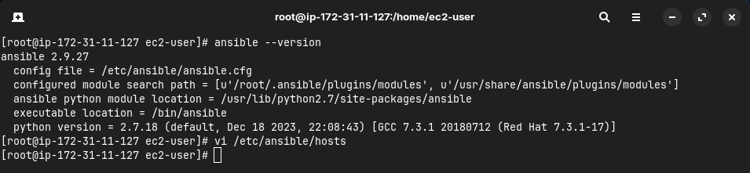

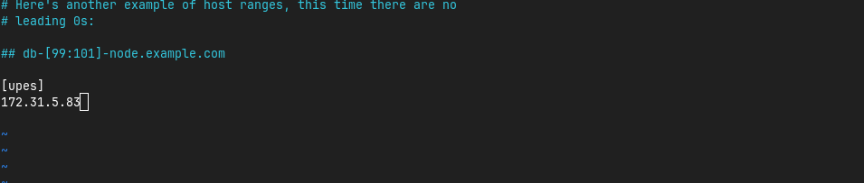

4. Create super user in both the machines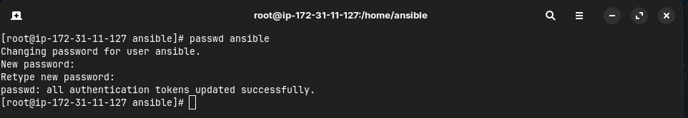

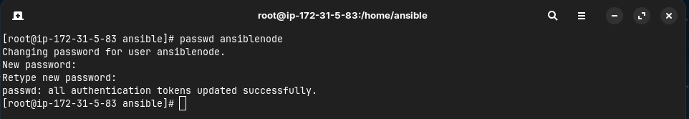

5. Give sudo user permissions to both users

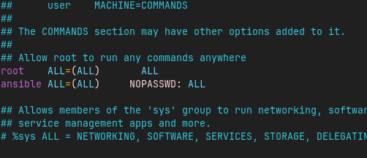

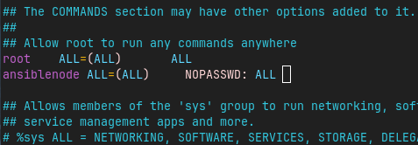

6. Edit the sshd_config file in the node server

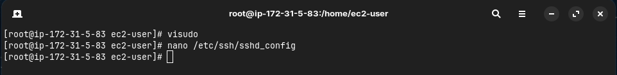

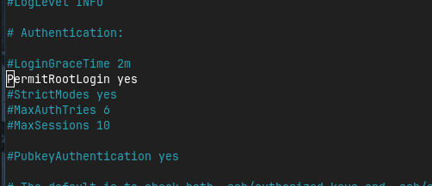

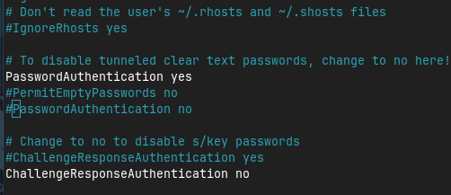

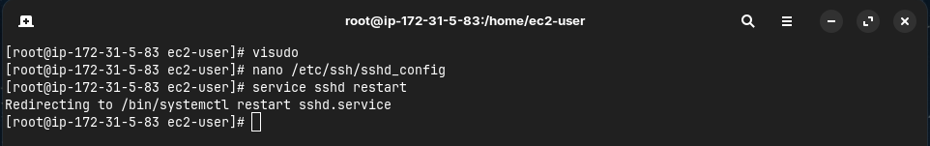

7. Generate key pair in Ansible server and copy the key to node server

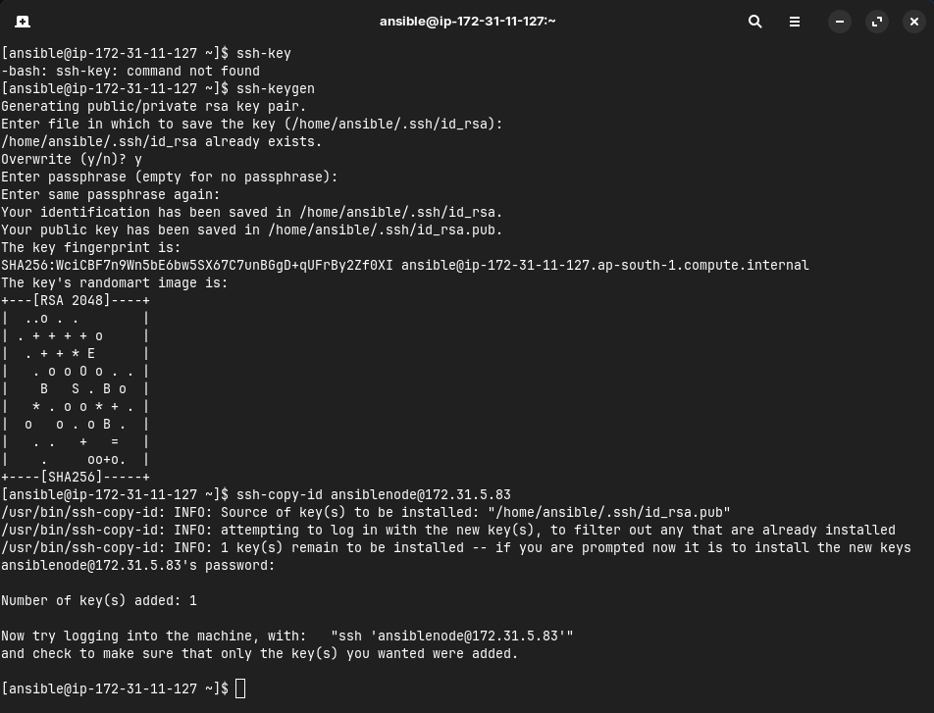

8. Connect to node server from ansible server

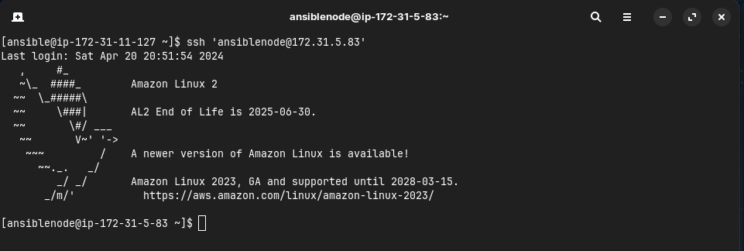

**Experiment 12**

**Create Run Ansible Playbooks**

**Steps**

1. Repeat the steps in Experiment 11 to create the initial setup

2. Test adhoc commands

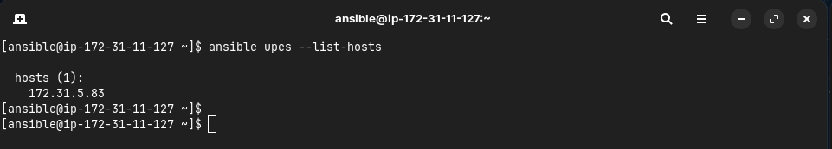

3. Install Apache server on node server using adhoc command

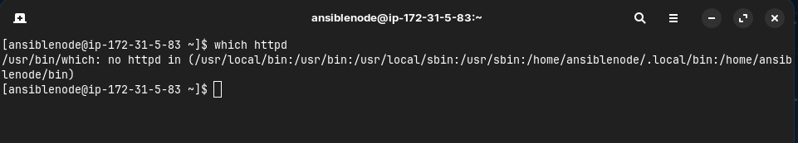

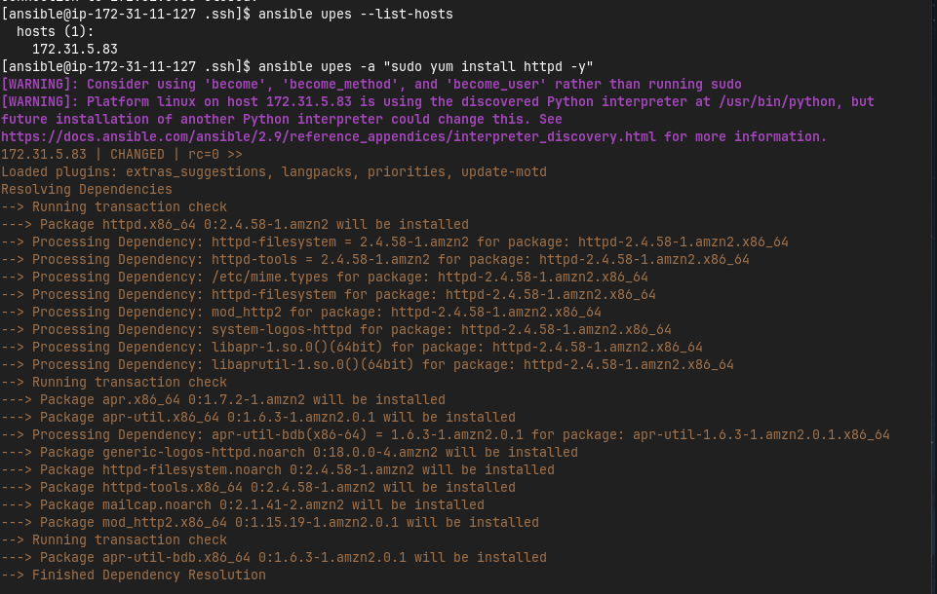

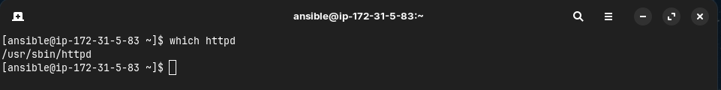

4. Start the httpd service using ansible

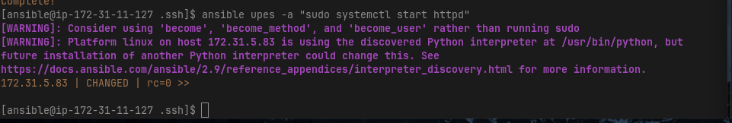

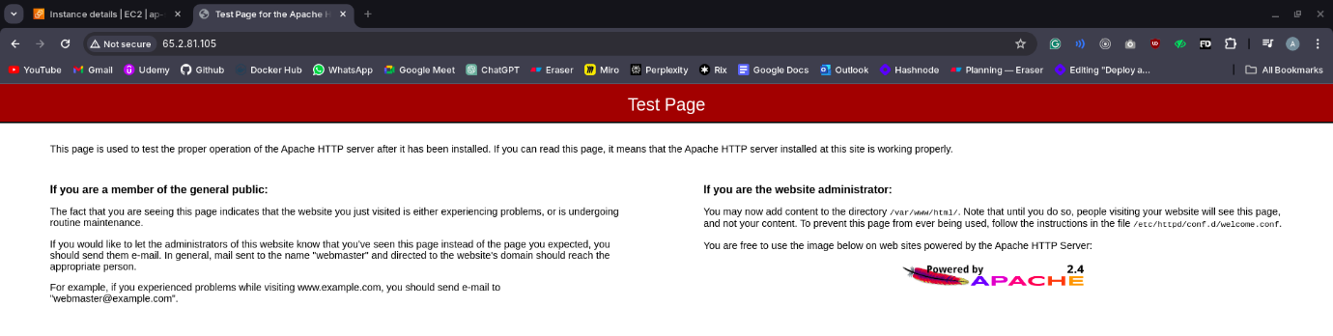

5. Remove ansbile and then reinstall using ansible playbook

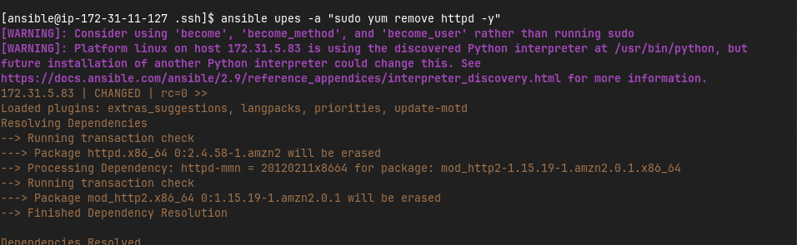

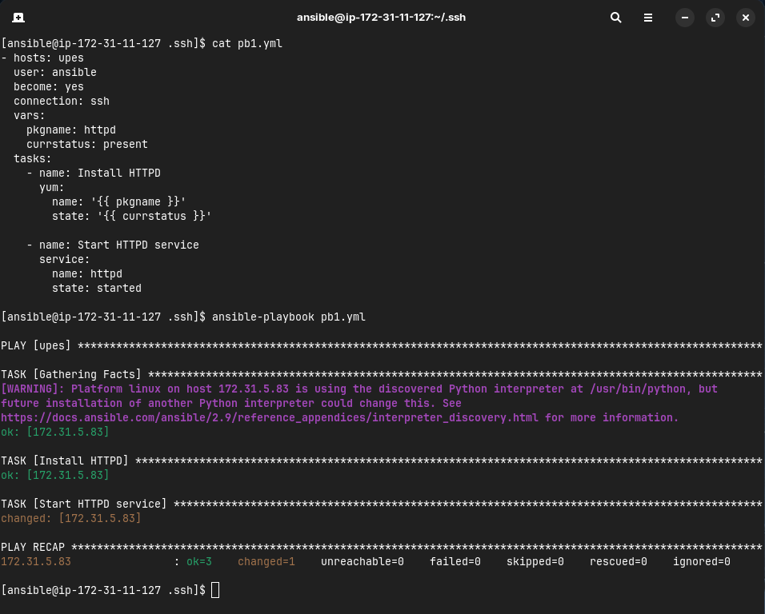



6. Testing other playbooks

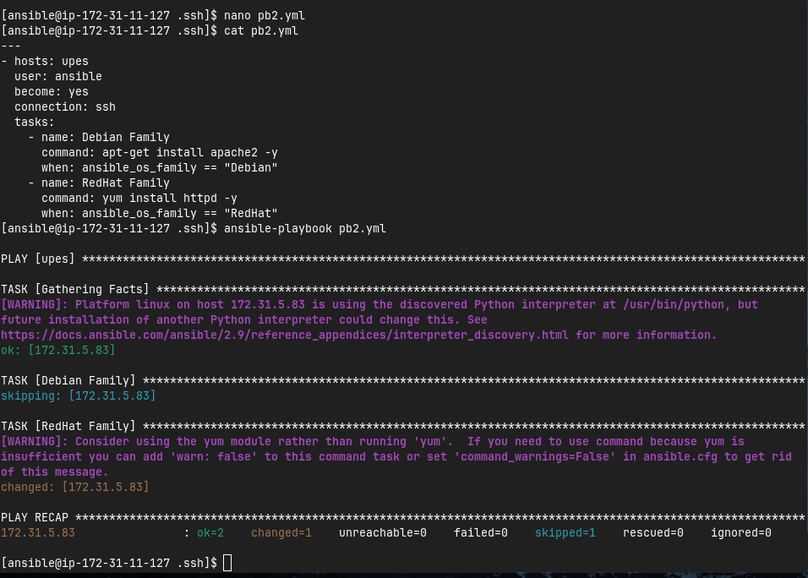

v